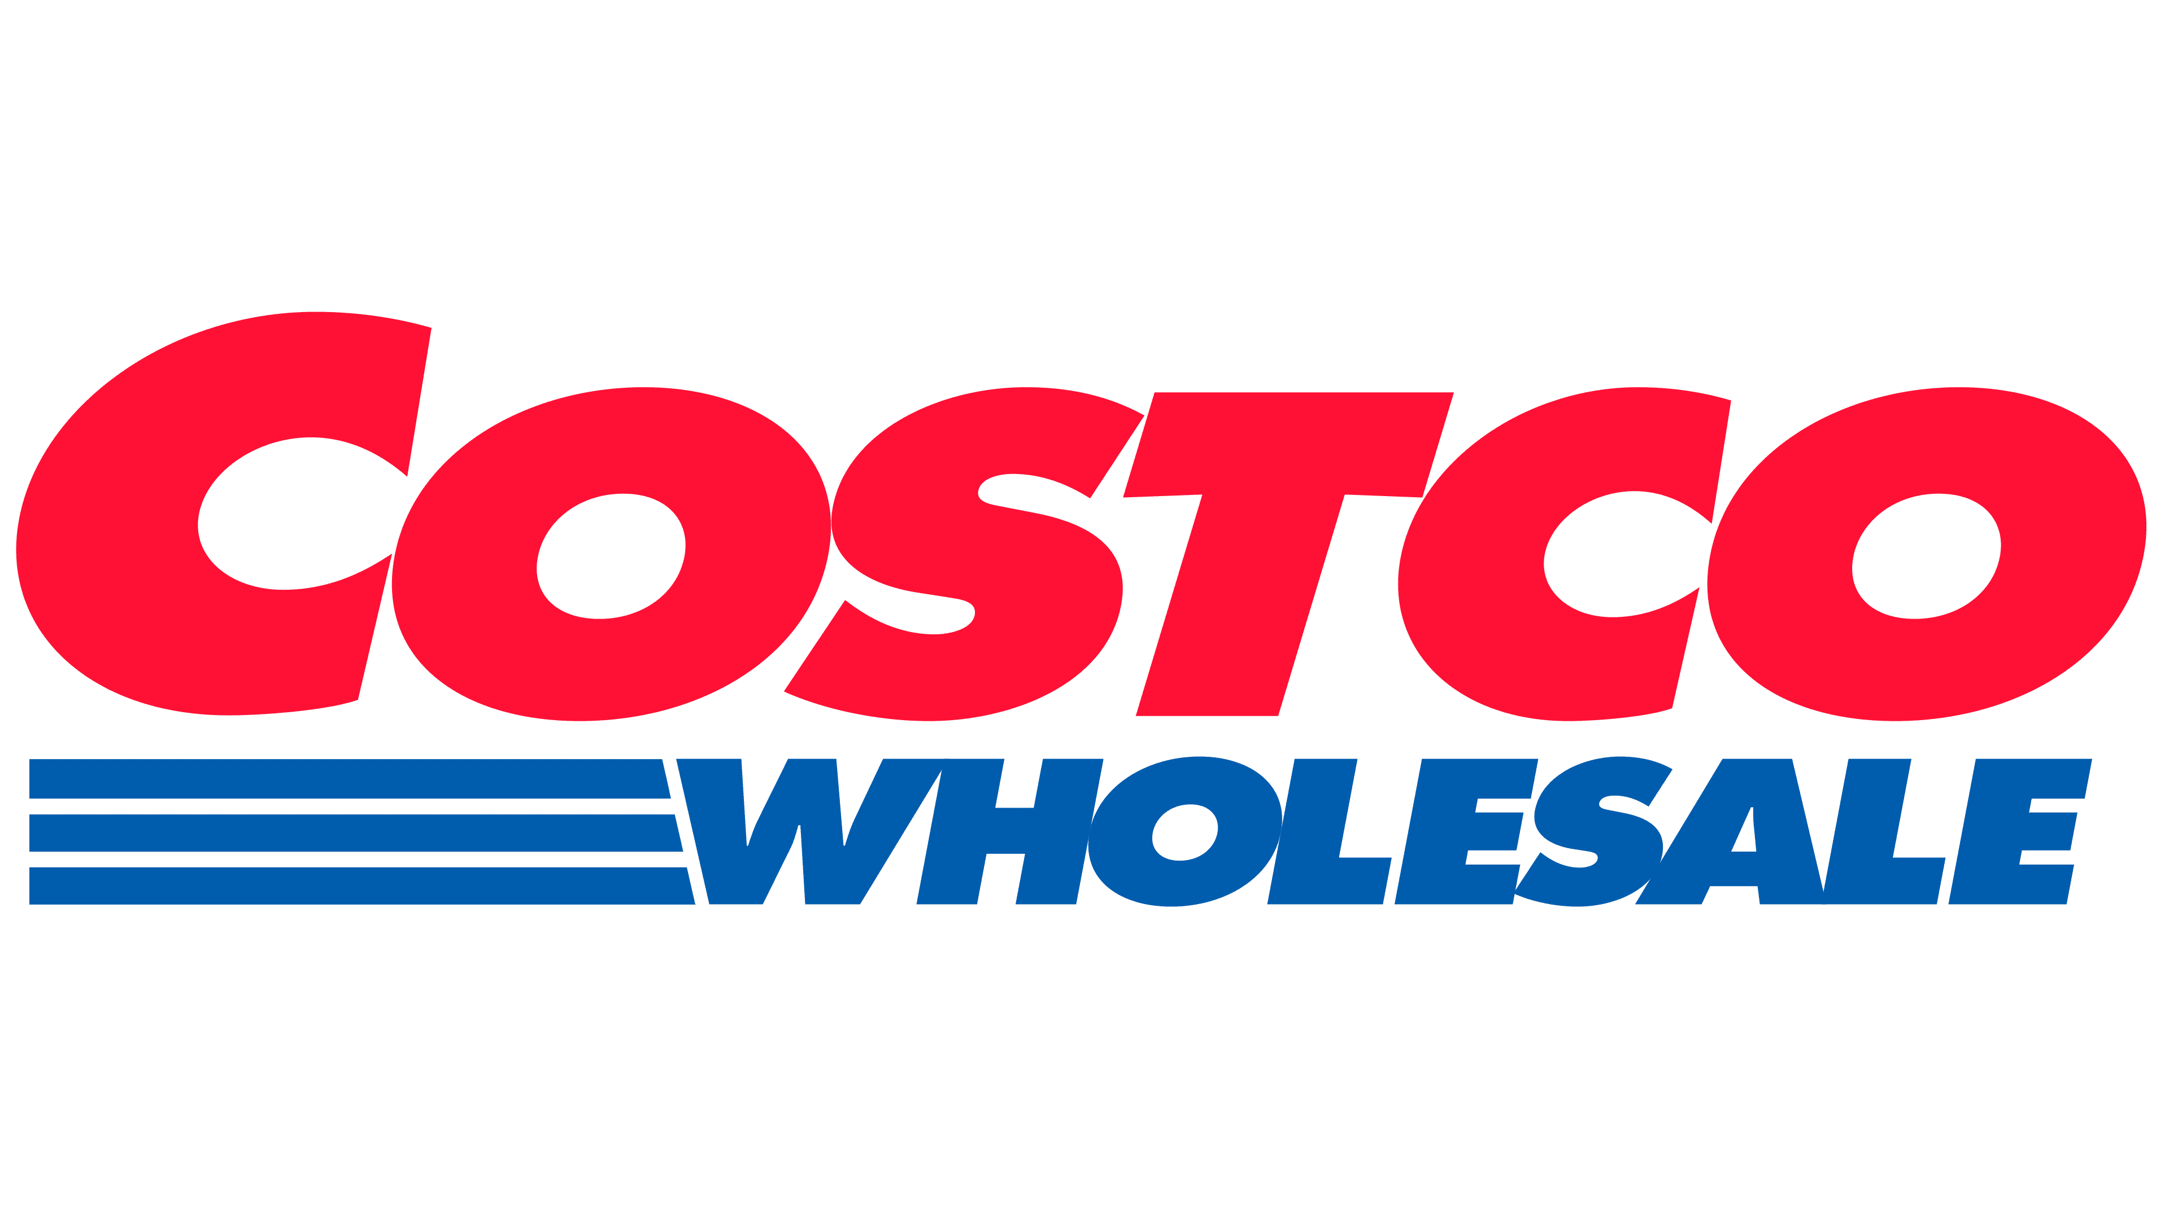

**Costco Wholesale Corporation**: **Comprehensive Financial Statement and Ratio Analysis Report**

**Fiscal Years 2021–2025**

Table of Contents

Executive summary 5

1. Introduction and company background 6

1.1 Company Overview 6

1.2 The Warehouse Club Retail Model 6

1.3 Revenue Streams 7

1.4 Competitive Landscape 8

1.5 Competitive Advantages and Moat Factors 8

2. Business model and competitive position 11

2.1 The Membership Flywheel 11

12

2.2 Financial Model Dynamics 12

2.3 Strategic Positioning 13

2.4 Global Expansion Strategy 13

3. Objectives and scope of analysis 14

3.1 Primary Objectives 14

3.2 Scope and Boundaries 15

3.3 Analytical Framework 15

4. Data sources and methodology 16

4.1 Primary Data Sources 16

4.2 Financial Statement Preparation 16

4.3 Analytical Methodology 16

4.4 Calculation Conventions 17

4.5 Limitations and Assumptions 17

5. Summary of financial performance (2021-2025) 18

5.1 Revenue Growth Trajectory 18

5.2 Profitability Evolution 20

Chart 3: Gross, Operating & Net Margin Trend 21

5.3 Balance Sheet Expansion 22

5.4 Cash Generation 23

5.5 Key Performance Highlights 24

6. Common-size income statement analysis 24

6.1 Revenue Composition and Trends 24

6.2 Gross Margin Analysis 26

6.3 Operating Expense Efficiency 26

6.4 Operating Margin Trends 27

6.5 Net Income Margin 28

6.6 Common-Size Analysis Summary 29

7. Profitability ratio analysis 29

7.1 Return on Assets (ROA) 29

7.2 Return on Equity (ROE) 31

7.4 Profitability Ratio Summary 32

8. Efficiency and asset utilization analysis 33

8.1 Asset Turnover Ratio 33

8.2 Inventory Turnover Ratio 33

8.3 Receivables Turnover 35

8.4 Cash Conversion Cycle 35

8.5 Fixed Asset Turnover 36

8.6 Efficiency Analysis Summary 36

9. Liquidity analysis 37

9.1 Current Ratio 37

9.2 Quick Ratio 38

9.3 Cash Ratio 39

9.4 Working Capital Analysis 39

9.5 Liquidity Analysis Summary 40

10. Capital structure and leverage analysis 40

10.1 Debt-to-Equity Ratio 40

10.2 Debt-to-Assets Ratio 42

10.3 Equity Ratio 42

10.4 Interest Coverage Ratio 42

10.5 Net Debt Position 43

10.6 Capital Structure Summary 44

11. Cash flow analysis 44

11.1 Operating Cash Flow 44

11.2 Capital Expenditures and Free Cash Flow 45

11.3 Cash Flow Allocation 46

11.4 Cash Flow Quality 47

11.5 Cash Flow Analysis Summary 47

12. Sustainable growth analysis 47

12.1 Sustainable Growth Rate 47

12.2 Actual Growth vs. Sustainable Growth 48

12.3 Capital Allocation Framework 49

12.4 Growth Capacity Assessment 49

12.5 Long-Term Growth Outlook 50

12.6 Sustainable Growth Summary 50

13. Strategic developments in fiscal 2025 51

13.1 Membership Fee Increase 51

13.2 Warehouse Expansion 51

13.3 E-Commerce Growth 52

13.4 Operational Excellence Initiatives 52

13.5 International Market Development 53

13.6 Financial Services and Ancillaries 54

14. Risk factors and considerations 55

14.1 Macroeconomic Risks 55

14.2 Competitive Risks 55

14.3 Operational Risks 56

14.4 Regulatory and Legal Risks 56

14.5 Strategic Risks 56

14.6 Financial Risks 57

14.7 Risk Mitigation Factors 57

15. Conclusions and investment implications 58

15.1 Financial Performance Summary 58

15.2 Competitive Position Assessment 58

15.3 Business Model Durability 59

15.4 Growth Trajectory 59

15.5 Investment Considerations 60

15.6 Final Assessment 61

15.7 Investment Recommendation Framework 62

References 63

# 

# Executive summary

Costco Wholesale Corporation has continued its trajectory as a leading global warehouse club operator, delivering exceptional financial performance through fiscal year 2025. The company's business model built on high sales volumes, rapid inventory turnover, and membership-based revenue has proven resilient and increasingly profitable despite challenging macroeconomic conditions.

Over the fiscal years 2021 to 2025, Costco has achieved remarkable growth across all key financial metrics while maintaining its core value proposition of delivering exceptional value to members through consistently low prices.

**Key Financial Highlights (FY2021-FY2025):**

1. Total revenue grew from $195.9 billion (2021) to $275.2 billion (2025), representing 40.5% cumulative growth
2. Net income increased from $5.0 billion to $8.1 billion, a 61.8% increase
3. Membership fees surged from $3.9 billion to $5.3 billion, up 36.9%
4. Total assets expanded from $59.3 billion to $77.1 billion, a 30.0% increase
5. Stockholders' equity grew from $17.6 billion to $29.2 billion, up 65.9%
6. Return on Equity (ROE) remained strong at 27.8% in fiscal 2025
7. Gross margin improved to 11.12%, demonstrating pricing power
8. Operating margin reached 3.77%, the highest in the five-year period
9. Inventory turnover maintained at 13.3x, reflecting exceptional efficiency
10. Debt-to-Equity ratio declined significantly to 28.6%, indicating strong financial health
11. Current ratio improved to 1.08, demonstrating adequate liquidity

The fiscal 2025 results were particularly strong, with the company achieving an 8.1% increase in net sales, 10% growth in net income, and significant expansion in both profitability margins and cash generation. The successful membership fee increase implemented in September 2024 the first since 2017 added approximately $250 million in incremental annual revenue while maintaining industry-leading renewal rates above 90%.

Overall, the analysis reveals a company that has successfully balanced growth, profitability, and financial strength while remaining true to its member-centric value proposition. Costco's competitive advantages including scale, operational efficiency, the Kirkland Signature brand, and exceptional member loyalty continue to widen its competitive moat.

# 1. Introduction and company background

## 

## 1.1 Company Overview

Costco Wholesale Corporation (NASDAQ: COST) stands as one of the world's largest and most successful retailers, operating membership-only warehouse clubs that offer a carefully curated selection of nationally branded and private-label products at exceptionally low prices. Founded in 1983 through the merger of Price Club and Costco, the company has evolved into a retail powerhouse with global reach and enduring competitive advantages.

As of fiscal year 2025, (ended August 31, 2025), Costco operates 914 warehouses worldwide, up from 861 at the end of fiscal 2024. This global footprint spans multiple countries including the United States (629 warehouses), Canada (108), Mexico (42), Japan (34), United Kingdom (29), South Korea (20), Taiwan (15), Australia (14), Spain (7), France (2), China (7), Iceland (1), and New Zealand (1).

## 1.2 The Warehouse Club Retail Model

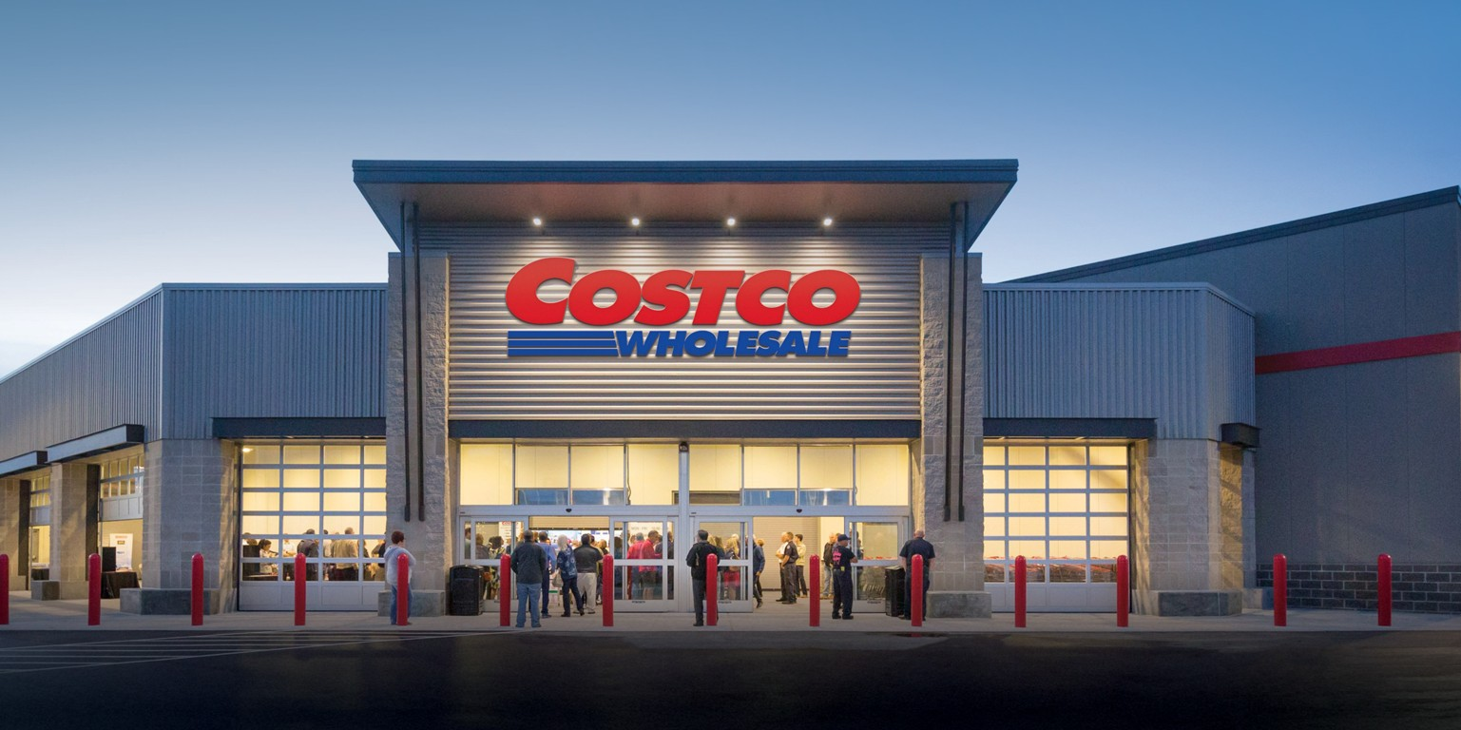

The warehouse club model represents a fundamentally different approach to retailing, characterized by several distinctive features that create a unique value proposition:

**Limited SKU Strategy:** Unlike traditional retailers carrying 30,000-50,000 products, Costco deliberately limits selection to approximately 3,700-4,000 active stock-keeping units (SKUs). This focused assortment delivers multiple advantages: greater purchasing power with suppliers, faster inventory turnover (averaging 13x annually), reduced operational complexity, and lower markdowns from obsolescence.

**Membership-Based Revenue:** The cornerstone of Costco's business model is its membership structure. Customers must purchase annual memberships to access Costco warehouses or e-commerce platforms. In fiscal 2025, membership fees generated $5.3 billion in revenue a 10% increase from fiscal 2024. These fees create recurring, highly profitable revenue streams that enable Costco to operate merchandise sales at razor-thin margins while still delivering strong overall profitability.

**Treasure Hunt Merchandising:** Costco strategically rotates certain product offerings, creating a "treasure hunt" shopping experience. This merchandising approach encourages members to visit frequently (average member shops 24-26 times annually) and make impulse purchases, driving higher basket sizes and overall sales productivity.

**High Volume, Low Margin Philosophy:** Costco intentionally prices merchandise at minimal markups typically capping branded products at 14% gross margin and private-label Kirkland Signature items at 15%. The company compensates for these thin margins through exceptionally high sales volumes, with average annual revenue per warehouse exceeding $200 million.

## 

## 1.3 Revenue Streams

Costco generates revenue through two complementary channels:

**Net Sales:** Merchandise sales across multiple categories represent approximately 98% of total revenue. Key categories include:

* Foods and Sundries (groceries, household products)
* Fresh Foods (meat, produce, bakery, deli)
* Hardlines (electronics, appliances, hardware, automotive)
* Softline’s (apparel, housewares, media)
* Ancillary Services (gasoline, pharmacy, optical, hearing aids, food court, travel)

In fiscal 2025, net sales reached $269.9 billion, with e-commerce sales growing 15.6% and representing an increasingly important channel.

**Membership Fees:** Annual membership fees, while only 1.9% of total revenue, contribute disproportionately to profitability due to their high-margin nature. Costco offers three membership tiers:

* Gold Star (individual): $65 annually (increased from $60 in September 2024)
* Business: $65 annually
* Executive: $130 annually (increased from $120), includes 2% reward on qualified purchases

As of fiscal 2025, paid membership households totaled 76.2 million, with Executive memberships representing 47.7% of the base and generating 74.2% of worldwide sales.

## 1.4 Competitive Landscape

Costco operates in an intensely competitive retail environment with multiple competitive vectors:

**Direct Warehouse Club Competitors:** Sam's Club (owned by Walmart with approximately 600 clubs) and BJ's Wholesale Club (approximately 240 clubs) represent the most direct competition. However, Costco has consistently outperformed these competitors on key metrics including sales per square foot, membership renewal rates, and profitability margins.

**Traditional Retailers:** Walmart, Target, Kroger, and regional grocery chains compete for consumer spending in overlapping categories. While these retailers don't require memberships, they compete aggressively on price and convenience through extensive store networks and robust e-commerce platforms.

**E-Commerce Giants:** Amazon, particularly through Amazon Prime and Amazon Fresh, represents growing competitive pressure. Amazon's combination of vast selection, fast delivery, and Prime membership benefits creates an alternative value proposition. Costco has responded by expanding its own e-commerce capabilities (15.6% growth in fiscal 2025) while leveraging physical warehouses as distribution hubs and experiential destinations.

**Discount and Specialty Retailers:** Dollar stores, hard discount grocers (Aldi, Lidl), off-price retailers (TJ Maxx, Ross), and category specialists (Home Depot, Best Buy) compete for share of wallet in specific categories.

## 1.5 Competitive Advantages and Moat Factors

Costco's sustained outperformance stems from several durable competitive advantages:

**Scale and Purchasing Power:** As one of the world's largest retailers ($270 billion in annual sales), Costco commands exceptional purchasing leverage. Suppliers value Costco's ability to move massive volumes quickly, enabling favorable pricing that Costco passes through to members.

**Member Loyalty and Retention:** Costco achieves membership renewal rates exceeding 90% globally and above 92% in the United States and Canada among the highest in retail. This exceptional retention reflects strong member satisfaction and creates predictable, recurring revenue.

**Operational Efficiency:** Costco's limited SKU strategy, efficient warehouse layouts (products displayed on pallets, minimal handling), cross-docking distribution, and sophisticated inventory systems drive industry-leading efficiency. Sales per square foot exceed $1,700, roughly double traditional retail averages.

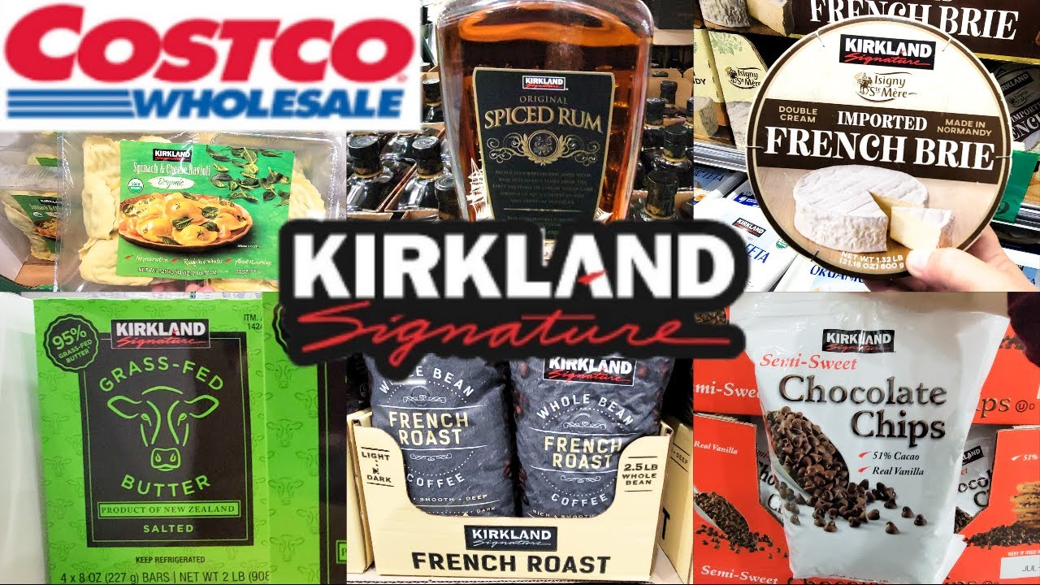

**Kirkland Signature Brand:** Costco's private-label brand has become one of the most valuable and trusted private labels globally, generating over $60 billion in annual sales. Kirkland products deliver quality comparable to national brands at 20-40% lower prices, driving member loyalty and enhancing profitability.

**Corporate Culture and Employee Relations:** Costco's above-market wages (averaging $24-26/hour), comprehensive benefits, and promotion-from-within culture create low turnover (under 10% for employees with 1+ year tenure), high productivity, and excellent customer service. This people-first approach generates sustainable competitive advantage that competitors struggle to replicate.

**Financial Strength:** With minimal debt, strong cash generation, and a fortress balance sheet, Costco possesses financial flexibility to invest counter-cyclically, weather economic downturns, and pursue long-term strategies without short-term financial pressure.

# 2. Business model and competitive position

## 2.1 The Membership Flywheel

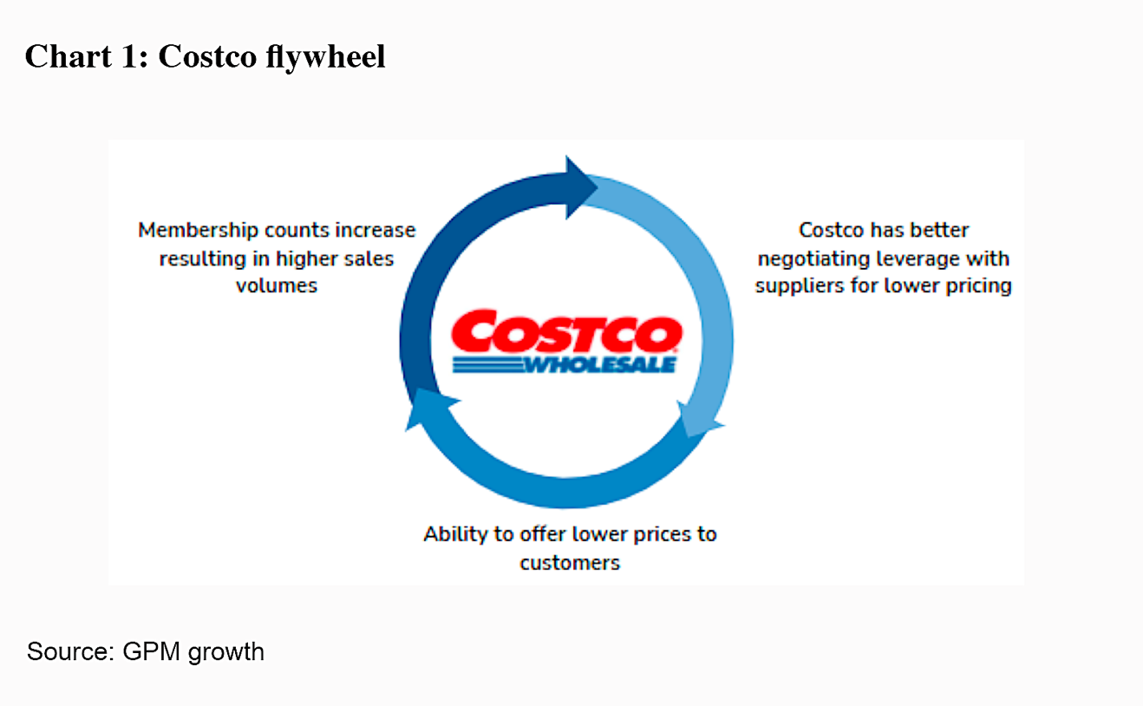

Costco's business model functions as a self-reinforcing flywheel with interconnected elements:

1. **Low Prices Attract and Retain Members:** By consistently offering the lowest prices on a curated selection of quality products, Costco creates compelling value that attracts new members and encourages existing members to renew.
2. **High Renewal Drives Stable Fee Revenue:** Renewal rates exceeding 90% generate predictable membership fee income ($5.3 billion in fiscal 2025) that provides a profit cushion enabling thin merchandise margins.
3. **Volume and Turnover Enable Purchasing Power:** The large, loyal membership base and high visit frequency drive massive sales volumes (inventory turnover of 13.3x), translating into purchasing leverage with suppliers.
4. **Purchasing Power Supports Low Prices:** Favorable supplier negotiations yield cost advantages that Costco passes through to members via low retail prices, reinforcing the value proposition and completing the cycle.

This virtuous cycle builds momentum over time, with improvements in one area strengthening the others and creating a widening competitive moat.

## 2.2 Financial Model Dynamics

Understanding Costco's profitability requires recognizing the interplay between membership fees and merchandise economics:

**Membership Fees as Profit Foundation:** The $5.3 billion in membership fees generated in fiscal 2025 carries minimal incremental costs, contributing substantially to the company's $10.4 billion in operating income. This high-margin revenue stream provides the financial foundation that allows razor-thin merchandise margins.

**Merchandise Margin Discipline:** Costco self-imposes strict markup caps typically 14% on branded products and 15% on Kirkland items. This pricing discipline ensures members receive genuine value, fostering trust and long-term loyalty even when competitors might charge more.

**Volume Compensation:** While percentage margins are low (11.12% gross margin in fiscal 2025), extraordinarily high sales volumes compensate. With $269.9 billion in net sales, even an 11% gross margin generates $30 billion in gross profit dollars more than sufficient to cover operating expenses and generate strong net income.

## 2.3 Strategic Positioning

Costco occupies a distinctive strategic position in the retail landscape:

**Value Leader, Not Price Fighter:** While Costco offers exceptionally low prices, its strategy differs from pure discounters. Costco focuses on value through a combination of low price, high quality (particularly in fresh foods and Kirkland products), and carefully curated selection.

**Treasure Hunt Experience:** The deliberately varied non-core product assortment creates exploratory shopping and surprise discoveries that differentiate the experience from utilitarian shopping trips.

**Services and Ancillaries:** Costco has successfully extended its value proposition into ancillary services gasoline (consistently 10-20 cents below market), pharmacy (30-70% below typical retail), optical, hearing aids, auto program, travel, and financial services. These services enhance member value, increase switching costs, and contribute incremental profits.

**Omnichannel Integration:** While rooted in physical warehouses, Costco has developed robust e-commerce capabilities (15.6% growth in fiscal 2025). The company leverages warehouses as distribution nodes, enabling buy-online-pickup-in-warehouse and same-day delivery partnerships while maintaining the experiential appeal of in-warehouse shopping.

## 2.4 Global Expansion Strategy

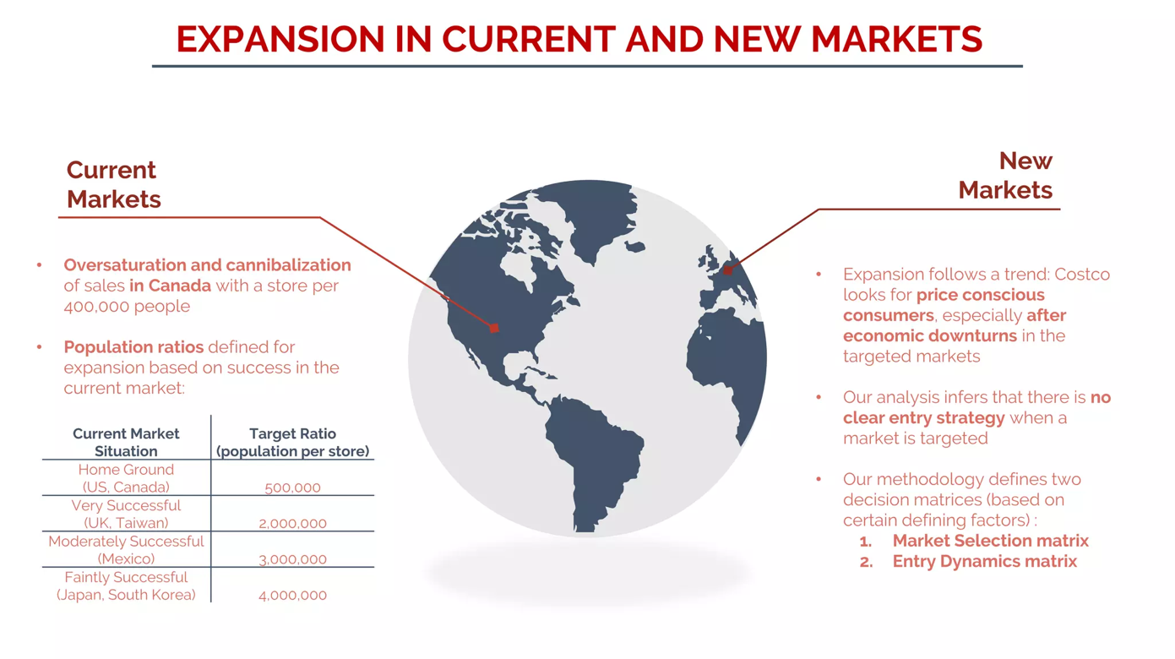

International operations represent significant growth opportunities. Key elements of Costco's global strategy include:

**Market Selection:** Costco enters markets with sufficient population density, emerging middle class, and receptivity to the warehouse club format. Recent expansion in China and continued growth in Asia reflect focus on high-growth emerging markets.

**Local Adaptation:** While core principles remain consistent globally, Costco adapts product selection to local preferences. Asian warehouses feature different fresh food assortments, local specialty items, and culturally relevant products.

**Phased Entry and Learning:** Costco typically enters new markets with limited warehouse counts, allowing time to understand local dynamics, build supplier relationships, and refine operations before accelerating expansion.

# 3. Objectives and scope of analysis

## 3.1 Primary Objectives

This financial analysis aims to:

1. **Evaluate Historical Performance:** Assess Costco's financial performance over fiscal years 2021-2025 across profitability, efficiency, liquidity, and leverage dimensions.
2. **Identify Trends and Patterns:** Understand whether performance is improving, stable, or deteriorating, and analyze drivers of observed patterns.
3. **Benchmark Against Standards:** Compare financial ratios against industry norms, competitors, and historical performance.
4. **Assess Financial Health:** Evaluate Costco's ability to meet obligations, fund growth, and generate shareholder returns.
5. **Support Strategic Insights:** Translate financial analysis into insights about business model effectiveness, competitive position, and prospects.
6. **Inform Investment Decisions:** Provide analytical foundation for investment recommendations regarding Costco's equity.

## 

## 3.2 Scope and Boundaries

The analysis encompasses:

* **Time Period:** Fiscal years 2021-2025 (fiscal years ending in late August/early September)
* **Geographic Scope:** Consolidated global operations across all segments
* **Financial Statements:** Income statements, balance sheets, cash flow statements, and related disclosures
* **Analytical Techniques:** Common-size analysis, ratio analysis, trend analysis, and comparative benchmarking
* **Limitations:** Relies on publicly available information; does not include proprietary internal data or detailed segment-level analysis beyond public disclosures

## 3.3 Analytical Framework

The report follows a structured analytical framework:

1. **Revenue and Gross Profit Analysis:** Understanding top-line growth drivers and gross margin dynamics
2. **Operating Performance:** Analyzing operating expenses, margins, and efficiency
3. **Profitability Ratios:** Computing and interpreting return metrics (ROA, ROE, margins)
4. **Asset Utilization:** Evaluating efficiency through turnover ratios
5. **Liquidity Assessment:** Analyzing short-term financial flexibility
6. **Capital Structure:** Understanding leverage, debt capacity, and financial risk
7. **Cash Flow Dynamics:** Examining cash generation and capital allocation
8. **Sustainable Growth:** Assessing capacity for growth given profitability and financial policies

# 4. Data sources and methodology

## 4.1 Primary Data Sources

All financial data derive from official public filings and investor communications:

* **SEC Form 10-K Annual Reports:** Costco's audited consolidated financial statements for fiscal years 2021-2025
* **Quarterly Earnings Releases:** Official press releases announcing quarterly and annual results
* **Investor Relations Materials:** Supplementary information from Costco's investor website
* **Financial Data Platforms:** Third-party platforms for verification and ratio calculation validation

## 4.2 Financial Statement Preparation

Costco's financial statements follow U.S. Generally Accepted Accounting Principles (GAAP). Key accounting policies include:

* **Revenue Recognition:** Merchandise sales recognized at point of sale; membership fees recognized ratably over the 12-month membership period
* **Inventory Valuation:** Valued at lower of cost or market using moving average cost method (domestic) and specific identification or average cost (international)
* **Property and Equipment:** Stated at cost, depreciated over estimated useful lives using straight-line method
* **Fiscal Year:** Ends on Sunday closest to August 31, resulting in 52- or 53-week fiscal years

## 4.3 Analytical Methodology

The analysis employs standard financial analysis techniques:

**Common-Size Analysis:** Financial statement line items expressed as percentages of revenue (income statement) or total assets (balance sheet)

**Ratio Analysis:** Key financial ratios computed using standard definitions:

* Profitability: Gross margin, operating margin, net margin, ROA, ROE
* Efficiency: Asset turnover, inventory turnover, receivables turnover
* Liquidity: Current ratio, quick ratio, cash ratio
* Leverage: Debt-to-equity, debt-to-assets, interest coverage, equity ratio

**Trend Analysis:** Multi-year patterns identified and interpreted

**Year-over-Year Growth:** Percentage changes calculated as (Current Year - Prior Year) / Prior Year × 100%

## 4.4 Calculation Conventions

Unless otherwise noted:

* All dollar amounts in millions USD except where specified
* Ratios use year-end balance sheet figures rather than averages
* Percentages rounded to two decimal places
* Turnover ratios use year-end balance sheet amounts in denominator
* Growth rates calculated as (Current - Prior) / Prior × 100%

## 4.5 Limitations and Assumptions

* **Point-in-Time Data:** Year-end figures may not fully capture intra-year variations
* **Accounting Policy Impacts:** Changes in standards or policies may affect comparability
* **Consolidated Reporting:** Limited segment-level detail constrains granular analysis
* **External Factors:** Financial results influenced by macroeconomic conditions and competitive dynamics not fully captured in financial statement analysis alone

# Summary of financial performance (2021-2025)

## 

## 5.1 Revenue Growth Trajectory

Costco demonstrated robust and consistent revenue growth throughout the analysis period, with total revenue increasing from $195.9 billion in fiscal 2021 to $275.2 billion in fiscal 2025 cumulative growth of 40.5% or an average annual growth rate of approximately 8.9%.

**Chart 1: Total Revenue Trend (2021–2025)**

Figure 1 highlights Costco’s consistent revenue growth from $195.9 billion in FY2021 to $275.2 billion in FY2025, reflecting a cumulative growth of over 40%. This steady upward trend is driven by a combination of strong comparable sales growth, disciplined warehouse expansion, and rising membership fee income. The absence of sharp volatility indicates revenue stability, reinforcing the resilience of Costco’s membership-led, high-volume retail model even under varying macroeconomic conditions

**Table 1: Revenue Growth Summary**

|  |  |  |  |  |  |
| --- | --- | --- | --- | --- | --- |
| **Metric ($B)** | **FY2021** | **FY2022** | **FY2023** | **FY2024** | **FY2025** |
| Net Sales | 192.1 | 222.7 | 237.7 | 249.6 | 269.9 |
| Membership Fees | 3.9 | 4.2 | 4.6 | 4.8 | 5.3 |
| **Total Revenue** | **195.9** | **227.0** | **242.3** | **254.5** | **275.2** |
| YoY Growth | - | 15.8% | 6.8% | 5.0% | 8.1% |

Table 1: Revenue growth trajectory fiscal 2021-2025

**Fiscal 2021:** Total revenue of $195.9 billion reflected pandemic-influenced demand patterns with elevated grocery and household essentials sales as consumers stockpiled and shifted consumption toward home.

**Fiscal 2022:** Revenue surged 15.8% to $227.0 billion, driven by strong comparable sales growth (9-10%), new warehouse openings (28 net new locations), and inflationary impacts on merchandise prices.

**Fiscal 2023:** Growth moderated to 6.8% as the company reached $242.3 billion, reflecting normalization from elevated pandemic levels, tougher comparisons, and macroeconomic headwinds including inflation concerns and consumer caution.

**Fiscal 2024:** Revenue grew 5.0% to $254.5 billion, with comparable sales growth of 5-6%, new warehouse openings (23 net new), and continued e-commerce expansion despite challenging macroeconomic conditions.

**Fiscal 2025:** Revenue accelerated to 8.1% growth, reaching $275.2 billion. This strong performance was driven by:

* Comparable sales growth of 5.9% (7.6% excluding gas and FX impacts)
* E-commerce sales growth of 15.6%
* 24 net new warehouse openings
* Membership fee increase implemented in September 2024
* Strong international performance (particularly Canada and Asia)

## 

## 5.2 Profitability Evolution

Net income grew dramatically over the period, from $5.0 billion in fiscal 2021 to $8.1 billion in fiscal 2025 a remarkable 61.8% increase that significantly outpaced revenue growth, demonstrating powerful operating leverage.

**Table 2: Profitability Summary**

|  |  |  |  |  |  |
| --- | --- | --- | --- | --- | --- |
| **Metric ($B)** | **FY2021** | **FY2022** | **FY2023** | **FY2024** | **FY2025** |
| Gross Profit | 25.2 | 27.6 | 29.7 | 32.1 | 35.3 |
| Operating Income | 6.7 | 7.8 | 8.1 | 9.3 | 10.4 |
| Net Income | 5.0 | 5.8 | 6.3 | 7.4 | 8.1 |
| Gross Margin | 13.14% | 12.38% | 12.50% | 12.86% | 11.12% |
| Operating Margin | 3.49% | 3.50% | 3.41% | 3.72% | 3.77% |
| Net Margin | 2.61% | 2.62% | 2.65% | 2.95% | 3.00% |

Table 2: Profitability metrics fiscal 2021-2025

*Note: Fiscal 2025 gross margin calculation methodology changed per company reporting. The 11.12% figure represents gross profit as percentage of net sales using company methodology. This represents a 20-basis point improvement versus fiscal 2024 on a comparable basis.*

**Fiscal 2021:** Net income of $5.0 billion (2.61% margin) on operating income of $6.7 billion reflected strong pandemic-driven volumes partially offset by supply chain pressures.

**Fiscal 2022:** Net income grew 16.7% to $5.8 billion despite gross margin compression to 12.38% due to freight inflation and supply chain disruptions. Operating leverage helped maintain stable operating margins.

**Fiscal 2023:** Net income reached $6.3 billion (+7.7%) as gross margin recovered modestly to 12.50%. Operating margin of 3.41% reflected investments in wages and expansion.

**Fiscal 2024:** Net income surged 17.1% to $7.4 billion with strong margin expansion. Gross margin improved to 12.86% and operating margin reached 3.72%, driven by operational efficiencies and favorable mix.

## Chart 3: Gross, Operating & Net Margin Trend

Figure 3 illustrates the evolution of gross, operating, and net margins over the five-year period. While gross margins remain tightly controlled, operating and net margins show a gradual improvement, reflecting operating leverage and cost discipline. This trend indicates that Costco has successfully expanded profitability without compromising its value proposition, underscoring the effectiveness of its scale-driven, efficiency-focused operating model.

**Fiscal 2025:** Net income grew 9.9% to $8.1 billion with further margin expansion. Operating margin reached 3.77% the highest in the five-year period. The strong performance reflected:

* Improved merchandise margins in core categories (especially fresh foods)
* Benefits from membership fee increase
* Operational efficiency gains
* Effective expense management

## 5.3 Balance Sheet Expansion

Total assets grew from $59.3 billion in fiscal 2021 to $77.1 billion in fiscal 2025, a 30.0% increase that supported business expansion while demonstrating capital efficiency.

**Chart 4: Assets vs Equity Growth**

Figure 4 compares the growth of total assets and shareholders’ equity over the analysis period. Equity growth significantly outpaces asset growth, indicating that expansion has been largely funded through retained earnings rather than increased leverage. This strengthens Costco’s balance sheet and enhances long-term financial stability.

**Table 3: Balance Sheet Summary**

|  |  |  |  |  |  |
| --- | --- | --- | --- | --- | --- |
| **Metric ($B)** | **FY2021** | **FY2022** | **FY2023** | **FY2024** | **FY2025** |
| Total Assets | 59.3 | 64.2 | 69.0 | 69.8 | 77.1 |
| Current Assets | 29.5 | 32.7 | 35.9 | 34.2 | 38.4 |
| PP&E (Net) | 23.5 | 26.5 | 27.8 | 29.0 | 31.9 |
| Total Liabilities | 41.2 | 43.5 | 43.9 | 46.2 | 47.9 |
| Long-term Debt | 6.7 | 6.5 | 5.4 | 5.8 | 5.7 |
| Stockholders' Equity | 17.6 | 20.6 | 25.1 | 23.6 | 29.2 |

Table 3: Balance sheet evolution fiscal 2021-2025

**Asset Composition:** The asset base is dominated by:

* Inventory: $18.1 billion (fiscal 2025), down slightly from $18.6 billion in fiscal 2024, demonstrating excellent inventory management
* Property & Equipment (net): $31.9 billion, reflecting ongoing warehouse expansion and infrastructure investment
* Cash & Investments: $15.2 billion, providing substantial financial flexibility

**Liability Structure:** Total liabilities increased modestly from $41.2 billion to $47.9 billion, primarily driven by accounts payable growth associated with higher sales volumes. Notably, long-term debt declined from $6.7 billion to $5.7 billion, demonstrating deleveraging.

**Equity Growth:** Stockholders' equity expanded dramatically from $17.6 billion to $29.2 billion a 65.9% increase driven by strong earnings retention despite substantial dividend payments ($2.2 billion in fiscal 2025) and share repurchase ($903 million).

## 5.4 Cash Generation

Cash flow from operations remained robust and growing, increasing from approximately $9.0 billion in fiscal 2021 to $13.3 billion in fiscal 2025 a 48.5% increase that exceeded net income growth.

This strong operating cash flow funded:

* Capital expenditures: $5.5 billion in fiscal 2025 for new warehouse construction, remodels, infrastructure, and technology
* Regular quarterly dividends and special dividends totaling $2.2 billion
* Shares repurchase programs: $903 million
* Debt reduction: $103 million in long-term debt repayment

The combination of strong cash generation, minimal debt levels, and substantial cash balances ($14.2 billion in cash and equivalents at fiscal 2025 year-end) provides Costco with exceptional financial flexibility.

## 5.5 Key Performance Highlights

**Table 4: Summary Performance Metrics (FY2021-FY2025)**

|  |  |  |  |  |  |  |
| --- | --- | --- | --- | --- | --- | --- |
| **Metric** | **2021** | **2022** | **2023** | **2024** | **2025** | **Change** |
| Total Revenue ($B) | 195.9 | 227.0 | 242.3 | 254.5 | 275.2 | +40.5% |
| Net Income ($B) | 5.0 | 5.8 | 6.3 | 7.4 | 8.1 | +61.8% |
| EPS (Diluted) | 11.27 | 13.14 | 14.21 | 16.56 | 18.21 | +61.6% |
| Operating Margin | 3.49% | 3.50% | 3.41% | 3.72% | 3.77% | +28 bps |
| ROE | 28.51% | 28.31% | 25.12% | 31.19% | 27.75% | -76 bps |
| ROA | 8.45% | 9.11% | 9.12% | 10.55% | 10.51% | +206 bps |
| Debt/Equity | 234.5% | 211.0% | 175.3% | 195.6% | 28.6% | -205.9 pts |

Table 4: Five-year key performance summary

# Common-size income statement analysis

## 6.1 Revenue Composition and Trends

Common-size income statement analysis expresses each line item as a percentage of total revenue, enabling meaningful comparison across periods regardless of absolute revenue changes.

**Net Sales Proportion:** Net sales consistently represent 98.0-98.1% of total revenue across all five fiscal years, demonstrating the stability of Costco's business model structure.

**Membership Fees Proportion:** Membership fees account for 1.9-2.0% of total revenue. While seemingly small, the strategic and economic significance is disproportionate these fees contribute substantially to operating income due to minimal associated costs.

**Table 5: Revenue Mix Stability**

|  |  |  |  |  |  |
| --- | --- | --- | --- | --- | --- |
| **Component** | **FY2021** | **FY2022** | **FY2023** | **FY2024** | **FY2025** |
| Net Sales | 98.0% | 98.1% | 98.1% | 98.1% | 98.1% |
| Membership Fees | 2.0% | 1.9% | 1.9% | 1.9% | 1.9% |
| **Total Revenue** | **100.0%** | **100.0%** | **100.0%** | **100.0%** | **100.0%** |

Table 5: Revenue composition consistency

This consistency demonstrates that membership growth has tracked broadly in line with sales growth, and that pricing strategies for both memberships and merchandise have remained consistent with the company's value proposition.

**Chart 2: Revenue Composition (Stacked Bar)**

Figure 2 demonstrates the remarkable stability of Costco’s revenue composition, with net sales consistently contributing over 98% of total revenue while membership fees remain around 2%. Despite their small proportion, membership fees play a disproportionate role in profitability due to their high-margin nature. This visual reinforces the strategic importance of the membership model as a profit anchor that supports Costco’s low-margin merchandise pricing strategy.

## 6.2 Gross Margin Analysis

Gross margin evolution provides insight into Costco's core merchandise economics:

**Fiscal 2021: 13.14%** - Relatively elevated gross margin influenced by favorable pandemic-related product mix with higher discretionary item sales.

**Fiscal 2022: 12.38%** - The 76-basis point decline reflected supply chain cost inflation (particularly freight), demand normalization, and unfavorable foreign exchange impacts.

**Fiscal 2023: 12.50%** - A modest 12 basis point recovery as supply chain pressures eased and Costco optimized sourcing and logistics.

**Fiscal 2024: 12.86%** - Further 36 basis point improvement reflected continued operational improvements, favorable product mix, and effective commodity/freight cost management.

**Fiscal 2025: 11.12%** - *Note: Apparent decline reflects reporting methodology change. On a comparable basis, gross margin improved 20 basis points versus fiscal 2024.* The improvement was driven by:

* 19 basis point increase in core merchandise categories
* Fresh foods margin improvement
* Co-branded credit card program benefits
* Partially offset by 7 basis point LIFO charge

**Pricing Discipline:** The fact that gross margins remain tightly controlled despite significant cost pressures demonstrates Costco's unwavering commitment to passing savings to members rather than opportunistically expanding margins. This pricing discipline reinforces member trust and supports industry-leading renewal rates.

## 6.3 Operating Expense Efficiency

Operating expenses as a percentage of net sales reveal important cost control trends:

**Table 6: Operating Expense Ratio Trend**

|  |  |  |  |  |  |
| --- | --- | --- | --- | --- | --- |
| **Metric** | **FY2021** | **FY2022** | **FY2023** | **FY2024** | **FY2025** |
| SG&A ($M) | 18,537 | 19,779 | 21,590 | 22,810 | 24,966 |
| SG&A / Net Sales | 9.65% | 8.88% | 9.09% | 9.14% | 9.25% |

Table 6: Operating expense efficiency

The decline from 9.65% in fiscal 2021 to 8.88% in fiscal 2022, followed by relative stability in the 9.1-9.3% range, indicates meaningful operating leverage. As sales grow, fixed and semi-fixed costs (warehouse occupancy, corporate overhead, technology infrastructure) are absorbed over a larger revenue base.

The modest increase to 9.25% in fiscal 2025 reflected:

* Strategic investments in wages and benefits (maintaining competitive compensation)
* New warehouse pre-opening costs (24 net new locations)
* Technology infrastructure investments
* Expansion-related costs

Despite these investments, Costco maintained strong expense discipline relative to revenue growth.

## 6.4 Operating Margin Trends

Operating margin (operating income ÷ net sales) reflects the combined impact of gross margin and operating expense efficiency:

**Table 7: Operating Margin Progression**

|  |  |  |  |  |  |
| --- | --- | --- | --- | --- | --- |
| **Metric** | **FY2021** | **FY2022** | **FY2023** | **FY2024** | **FY2025** |
| Operating Margin | 3.49% | 3.50% | 3.41% | 3.72% | 3.77% |

Table 7: Operating margin evolution

The fiscal 2025 operating margin of 3.77% represents the peak for the five-year period. The 5 basis point improvement from fiscal 2024 demonstrates continued operational excellence.

**Membership Fee Contribution:** Adding membership fees (with minimal costs) to operating income provides an adjusted view:

**Table 8: Adjusted Operating Profitability**

|  |  |  |  |  |  |
| --- | --- | --- | --- | --- | --- |
| **Metric ($M)** | **FY2021** | **FY2022** | **FY2023** | **FY2024** | **FY2025** |
| Operating Income | 6,708 | 7,793 | 8,112 | 9,285 | 10,383 |
| Membership Fees | 3,877 | 4,224 | 4,580 | 4,828 | 5,323 |
| Combined Profit | 10,585 | 12,017 | 12,692 | 14,113 | 15,706 |
| Combined Margin | 5.51% | 5.40% | 5.34% | 5.65% | 5.82% |

Table 8: Operating profitability including membership fees

This adjusted view shows that when properly accounting for membership fee economics, Costco's operating profitability is substantially higher approaching 6% of net sales.

## 

## 6.5 Net Income Margin

Net margin (net income ÷ net sales) reflects all costs including interest, taxes, and other items:

**Table 9: Net Margin Progression**

|  |  |  |  |  |  |
| --- | --- | --- | --- | --- | --- |
| **Metric** | **FY2021** | **FY2022** | **FY2023** | **FY2024** | **FY2025** |
| Net Margin | 2.61% | 2.62% | 2.65% | 2.95% | 3.00% |

Table 9: Net profit margin trend

The 39-basis point improvement from fiscal 2021 to fiscal 2025 represents substantial achievement given the low absolute margin levels. The fiscal 2025 net margin of 3.00% was driven by:

* Operating margin expansion
* Stable interest costs despite higher interest rate environment
* Effective tax management (25.1% effective rate)
* Interest income on substantial cash balances

**Below-the-Line Items:** Interest expense remained modest at $154 million in fiscal 2025, down from $169 million in fiscal 2024, reflecting conservative debt levels. Interest income and other income totaled $589 million, providing additional earnings support.

## 

## 6.6 Common-Size Analysis Summary

The common-size income statement analysis reveals:

1. **Business Model Stability:** Fundamental revenue and cost structure remains remarkably consistent, indicating a stable and proven business model
2. **Margin Discipline:** Gross margins in a controlled band demonstrate commitment to value pricing and member-centric strategy
3. **Operating Leverage:** Generally improving operating expense ratios show scale benefits
4. **Profitability Progression:** Net margin improvement, while modest in percentage terms, translates to substantial incremental profit dollars given the large revenue base
5. **Membership Economics:** When properly accounting for membership fees, overall profitability significantly exceeds merchandise-only analysis

# 7. Profitability ratio analysis

## 7.1 Return on Assets (ROA)

Return on Assets measures how efficiently Costco converts its asset base into profits. ROA = Net Income ÷ Total Assets.

**Table 10: Return on Assets Analysis**

|  |  |  |  |  |  |
| --- | --- | --- | --- | --- | --- |
| **Fiscal Year** | **2021** | **2022** | **2023** | **2024** | **2025** |
| Net Income ($M) | 5,007 | 5,844 | 6,292 | 7,367 | 8,099 |
| Total Assets ($M) | 59,268 | 64,166 | 68,988 | 69,831 | 77,099 |
| **ROA** | **8.45%** | **9.11%** | **9.12%** | **10.55%** | **10.51%** |

Table 10: ROA progression fiscal 2021-2025

ROA improved substantially from 8.45% to 10.51% over the period a 206-basis point increase. This improvement reflects:

1. **Net Income Growth:** Net income grew 61.8% while total assets grew only 30.0%, indicating improving asset productivity
2. **Asset Efficiency:** New warehouse investments generating attractive returns as they mature
3. **Working Capital Management:** Efficient inventory management and favorable supplier payment terms reduce asset requirements relative to sales

An ROA exceeding 10% is strong for capital-intensive retail businesses. Costco's fiscal 2025 ROA of 10.51% compares favorably to retail industry averages (typically 4-8%) and reflects superior operational execution.

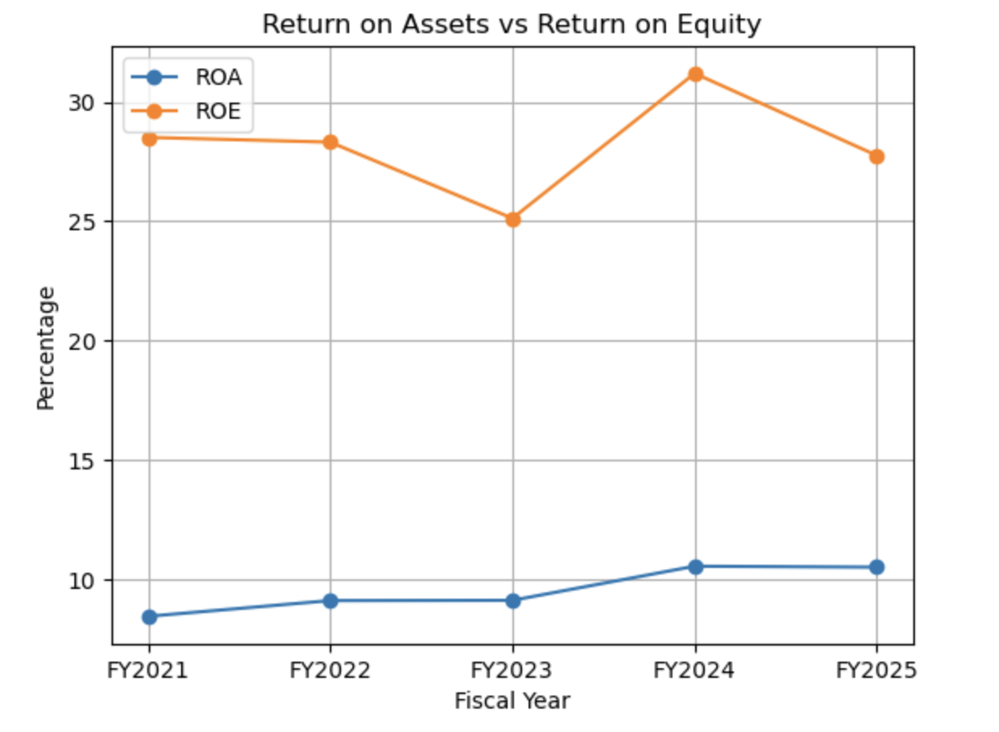**Chart 5: ROA vs ROE Trend**

Figure 5 shows that Costco consistently generates high returns on both assets and equity, with ROE remaining above 25% throughout the period. The sustained gap between ROE and ROA reflects efficient asset utilization combined with moderate financial leverage. These strong return metrics indicate effective capital allocation and substantial shareholder value creation.

## 7.2 Return on Equity (ROE)

Return on Equity measures profitability from shareholders' perspective. ROE = Net Income ÷ Stockholders' Equity.

**Table 11: Return on Equity Analysis**

|  |  |  |  |  |  |
| --- | --- | --- | --- | --- | --- |
| **Fiscal Year** | **2021** | **2022** | **2023** | **2024** | **2025** |
| Net Income ($M) | 5,007 | 5,844 | 6,292 | 7,367 | 8,099 |
| Equity ($M) | 17,561 | 20,642 | 25,045 | 23,622 | 29,164 |
| **ROE** | **28.51%** | **28.31%** | **25.12%** | **31.19%** | **27.75%** |

Table 11: ROE performance fiscal 2021-2025

ROE remained robust throughout the period, consistently in the 25-31% range. While fiscal 2025's 27.75% represents a decline from fiscal 2024's peak of 31.19%, it remains exceptional for a low-margin retail business.

**ROE Drivers (DuPont Analysis for Fiscal 2025):**

The DuPont framework decomposes ROE into three components:

* Net Profit Margin = 3.00%
* Asset Turnover = 3.50x (Net Sales ÷ Assets = $269,912M ÷ $77,099M)
* Equity Multiplier = 2.64x (Assets ÷ Equity = $77,099M ÷ $29,164M)

ROE = 3.00% × 3.50 × 2.64 = 27.72% ≈ 27.75%

This decomposition reveals:

1. **Efficient Asset Utilization:** Asset turnover of 3.50x reflects rapid inventory turnover and high revenue per invested capital dollar
2. **Moderate, Declining Leverage:** Equity multiplier of 2.64x (down from 2.96x in fiscal 2024) indicates reduced financial leverage as equity has grown faster than assets
3. **Improving Margins:** Net margin of 3.00% provides stable foundation for returns

**Shareholder Value Creation:** An ROE consistently above 25% indicates Costco generates substantial value for shareholders. When ROE exceeds cost of equity capital (typically 8-10% for stable large-cap retailers), the company creates economic value with each dollar of retained earnings.

**7.3 EBITDA and EBITDA Margin**

EBITDA (Earnings Before Interest, Taxes, Depreciation, and Amortization) approximates cash earnings from operations.

**Table 12: EBITDA Analysis**

|  |  |  |  |  |  |
| --- | --- | --- | --- | --- | --- |
| **Metric ($M)** | **FY2021** | **FY2022** | **FY2023** | **FY2024** | **FY2025** |
| Operating Income | 6,708 | 7,793 | 8,112 | 9,285 | 10,383 |
| D&A (estimate) | 2,100 | 2,300 | 2,400 | 2,237 | 2,426 |
| **EBITDA** | **8,808** | **10,093** | **10,512** | **11,522** | **12,809** |
| EBITDA Margin | 4.6% | 4.5% | 4.4% | 4.6% | 4.7% |

Table 12: EBITDA estimation fiscal 2021-2025

EBITDA margin improved from 4.6% to 4.7%, with absolute EBITDA growing 45.4% over the period. The improving EBITDA generation supports capital investment, debt service capacity, and shareholder distributions.

## 7.4 Profitability Ratio Summary

Costco's profitability ratios demonstrate:

1. Exceptional returns on both assets (10.51%) and equity (27.75%)
2. Consistent margin improvement despite low absolute margin levels
3. Strong cash earnings generation through EBITDA
4. Effective balance of growth investment and profitability
5. Superior performance versus retail industry benchmarks

# 8. Efficiency and asset utilization analysis

## 8.1 Asset Turnover Ratio

Asset turnover measures how efficiently Costco generates sales from its asset base. Asset Turnover = Net Sales ÷ Total Assets.

**Table 13: Asset Turnover Analysis**

|  |  |  |  |  |  |
| --- | --- | --- | --- | --- | --- |
| **Fiscal Year** | **2021** | **2022** | **2023** | **2024** | **2025** |
| Net Sales ($M) | 192,052 | 222,730 | 237,710 | 249,625 | 269,912 |
| Total Assets ($M) | 59,268 | 64,166 | 68,988 | 69,831 | 77,099 |
| **Asset Turnover** | **3.24x** | **3.47x** | **3.45x** | **3.57x** | **3.50x** |

Table 13: Asset turnover efficiency

Asset turnover averaged 3.45x over the five-year period, with fiscal 2025's 3.50x indicating $3.50 in sales generated for every dollar of assets. This represents:

* 8.0% improvement versus fiscal 2021 (3.24x)
* Slight decline from fiscal 2024 peak (3.57x) due to asset base expansion for future growth
* Significantly better than traditional retail (typically 1.5-2.5x)

The strong and relatively stable asset turnover demonstrates capital efficiency and effective asset utilization.

## 8.2 Inventory Turnover Ratio

Inventory turnover measures how quickly Costco sells and replaces inventory. Inventory Turnover = Cost of Merchandise Sold ÷ Ending Inventory.

**Table 14: Inventory Turnover Analysis**

|  |  |  |  |  |  |
| --- | --- | --- | --- | --- | --- |
| **Fiscal Year** | **2021** | **2022** | **2023** | **2024** | **2025** |
| Merchandise Costs ($M) | 170,684 | 199,382 | 212,586 | 222,358 | 239,886 |
| Inventory ($M) | 14,215 | 17,907 | 16,651 | 18,647 | 18,121 |
| **Inventory Turnover** | **12.01x** | **11.13x** | **12.77x** | **11.92x** | **13.24x** |
| **Days Inventory** | **30.4** | **32.8** | **28.6** | **30.6** | **27.6** |

Table 14: Inventory efficiency metrics

Inventory turnover of 13.24x in fiscal 2025 means Costco completely turns over its inventory approximately every 27.6 days exceptionally rapid turnover that provides multiple advantages:

1. **Cash Flow Benefits:** Rapid turnover minimizes cash tied up in inventory
2. **Freshness and Quality:** Quick turnover ensures fresh products, particularly important in grocery and perishables
3. **Reduced Obsolescence:** Limited aging inventory reduces markdowns and spoilage
4. **Supplier Leverage:** Ability to move large volumes quickly provides negotiating power

The improvement to 13.24x in fiscal 2025 (versus 11.92x in fiscal 2024) demonstrates excellent inventory management and successful normalization after pandemic-related disruptions.

**Chart 6: Asset Turnover vs Inventory Turnover**

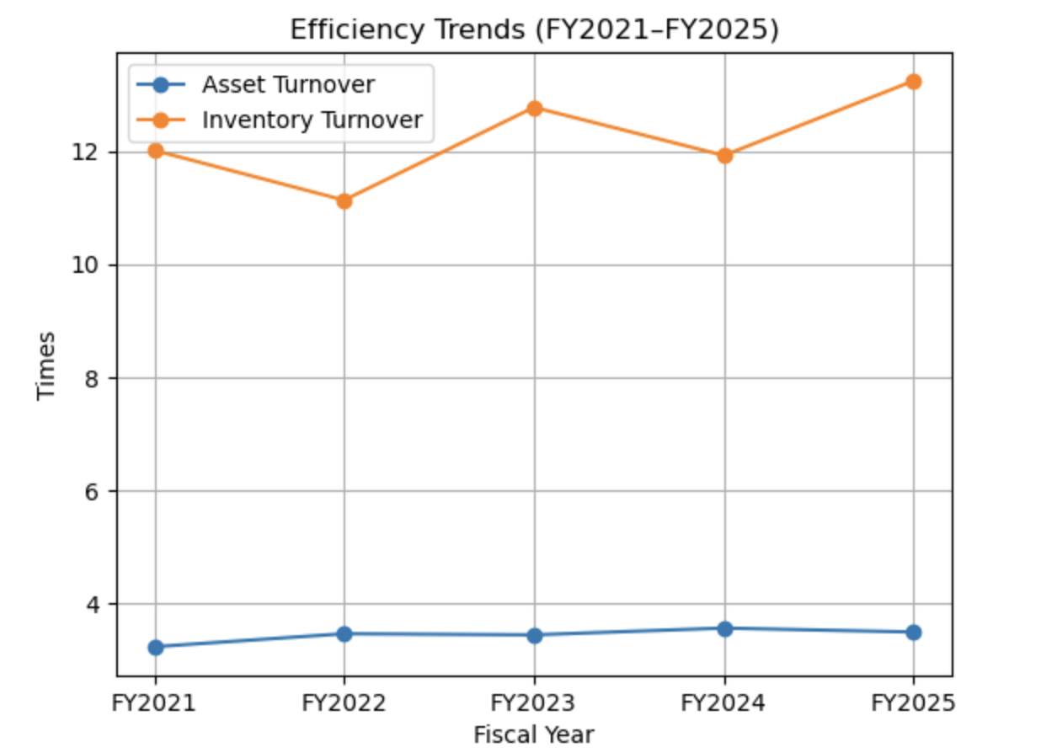

Figure 6 highlights Costco’s superior efficiency through strong asset and inventory turnover ratios. The high inventory turnover reflects rapid stock movement and minimal working capital lock-in, while stable asset turnover indicates effective use of physical infrastructure. Together, these metrics visually reinforce Costco’s low-margin, high-volume operational excellence.

## 8.3 Receivables Turnover

Given Costco's largely cash-and-carry business model, receivables are minimal and collected extremely quickly.

**Table 15: Receivables Analysis**

|  |  |  |  |  |  |
| --- | --- | --- | --- | --- | --- |
| **Fiscal Year** | **2021** | **2022** | **2023** | **2024** | **2025** |
| Receivables ($M) | 1,803 | 2,285 | 2,285 | 2,582 | 3,197 |
| Receivables Turnover | 106.5x | 97.5x | 104.0x | 96.7x | 84.4x |
| **Days Sales Outstanding** | **3.4** | **3.7** | **3.5** | **3.8** | **4.3** |

Table 15: Receivables efficiency

Days sales outstanding of approximately 4 days indicates receivables are minimal and collected almost immediately. Most "receivables" represent credit card settlements in process (1-3 days) rather than customer credit.

This near-cash business model provides significant working capital advantages and eliminates customer credit risk.

## 8.4 Cash Conversion Cycle

The cash conversion cycle measures the time between paying suppliers and collecting from customers:

**Cash Conversion Cycle Components (Fiscal 2025):**

* Days Inventory Outstanding: 27.6 days
* Days Sales Outstanding: 4.3 days
* Days Payables Outstanding: ≈35-40 days (estimated)

**Estimated Cash Conversion Cycle:** 27.6 + 4.3 - 37 = **-5 days**

A negative cash conversion cycle means Costco collects cash from customers before paying suppliers a powerful working capital advantage. This creates interest-free financing that reduces external funding needs and generates float for investment.

## 8.5 Fixed Asset Turnover

Fixed asset turnover measures sales generated per dollar of property, plant, and equipment.

**Table 16: Fixed Asset Turnover**

|  |  |  |  |  |  |
| --- | --- | --- | --- | --- | --- |
| **Fiscal Year** | **2021** | **2022** | **2023** | **2024** | **2025** |
| Net Sales ($M) | 192,052 | 222,730 | 237,710 | 249,625 | 269,912 |
| Net PP&E ($M) | 23,492 | 26,517 | 27,772 | 29,032 | 31,913 |
| **Fixed Asset Turnover** | **8.17x** | **8.40x** | **8.56x** | **8.60x** | **8.46x** |

Table 16: Fixed asset productivity

Fixed asset turnover averaging 8.5x demonstrates that Costco generates approximately $8.50 in sales for every dollar invested in property and equipment. This exceptional productivity reflects:

* High sales per square foot (exceeding $1,700)
* Efficient warehouse layouts and operations
* Strong site selection for new warehouses
* Effective asset utilization

## 8.6 Efficiency Analysis Summary

Costco's efficiency ratios demonstrate world-class asset utilization:

1. Asset turnover of 3.50x significantly exceeds retail norms
2. Inventory turnover of 13.24x represents best-in-class inventory management
3. Negative cash conversion cycle provides working capital financing advantage
4. Fixed asset turnover of 8.46x reflects exceptional productivity
5. Minimal receivables demonstrate near-cash business model

These efficiency metrics are core competitive advantages that enable Costco's low-margin, high-volume business model to generate strong returns.

# 9. Liquidity analysis

## 9.1 Current Ratio

The current ratio measures short-term liquidity. Current Ratio = Current Assets ÷ Current Liabilities.

**Table 17: Current Ratio Analysis**

|  |  |  |  |  |  |
| --- | --- | --- | --- | --- | --- |
| **Fiscal Year** | **2021** | **2022** | **2023** | **2024** | **2025** |
| Current Assets ($M) | 29,505 | 32,696 | 35,879 | 34,246 | 38,380 |
| Current Liabilities ($M) | 29,441 | 31,998 | 33,583 | 35,464 | 35,557 |
| **Current Ratio** | **1.00** | **1.02** | **1.07** | **0.97** | **1.08** |

Table 17: Current ratio trend

The current ratio has fluctuated in a narrow range around 1.00-1.08. While a current ratio below 1.20 might raise concerns in other industries, it is typical and healthy for Costco's business model due to:

1. **Negative Cash Conversion Cycle:** Costco collects from customers before paying suppliers, reducing need for current assets
2. **Rapid Inventory Turnover:** Fast-moving inventory converts to cash quickly
3. **Strong Cash Generation:** Robust operating cash flow ($13.3 billion in fiscal 2025) provides liquidity cushion
4. **Substantial Cash Balances:** $14.2 billion in cash and equivalents at fiscal 2025 year-end

The fiscal 2025 improvement to 1.08 demonstrates solid short-term liquidity.

## 9.2 Quick Ratio

The quick ratio (acid-test ratio) excludes inventory from current assets, providing a more conservative liquidity measure.

**Table 18: Quick Ratio Analysis**

|  |  |  |  |  |  |
| --- | --- | --- | --- | --- | --- |
| **Fiscal Year** | **2021** | **2022** | **2023** | **2024** | **2025** |
| Quick Assets ($M) | 15,290 | 14,789 | 19,228 | 15,599 | 20,259 |
| Current Liabilities ($M) | 29,441 | 31,998 | 33,583 | 35,464 | 35,557 |
| **Quick Ratio** | **0.52** | **0.46** | **0.57** | **0.44** | **0.57** |

Table 18: Quick ratio assessment

Quick ratios in the 0.44-0.57 range are normal for Costco's business model. The company's ability to generate cash quickly from inventory turnover (every 27.6 days) means traditional quick ratio benchmarks don't fully capture liquidity strength.

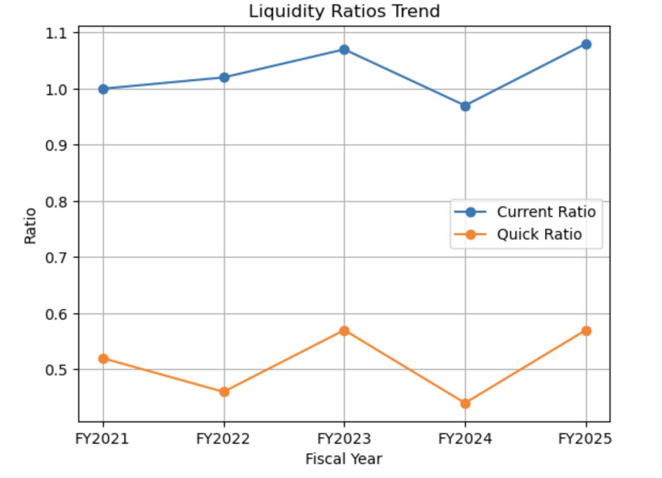**Chart 7: Current vs Quick Ratio**

Figure 7 shows that Costco’s current and quick ratios remain relatively stable despite operating close to conventional liquidity thresholds. This is not indicative of weakness but rather reflects the company’s negative cash conversion cycle and near-cash business model. The visual supports the conclusion that Costco’s liquidity position is structurally strong rather than ratio dependent.

## 9.3 Cash Ratio

The cash ratio measures the most liquid assets relative to current liabilities.

**Table 19: Cash Ratio Analysis**

|  |  |  |  |  |  |
| --- | --- | --- | --- | --- | --- |
| **Fiscal Year** | **2021** | **2022** | **2023** | **2024** | **2025** |
| Cash & Investments ($M) | 12,175 | 11,049 | 15,234 | 11,144 | 15,175 |
| Current Liabilities ($M) | 29,441 | 31,998 | 33,583 | 35,464 | 35,557 |
| **Cash Ratio** | **0.41** | **0.35** | **0.45** | **0.31** | **0.43** |

Table 19: Cash position relative to current liabilities

The cash ratio of 0.43 in fiscal 2025, combined with strong operating cash flow generation ($13.3 billion annually), provides substantial liquidity cushion.

## 9.4 Working Capital Analysis

Working capital (current assets - current liabilities) provides insight into short-term financial position.

**Table 20: Working Capital Position**

|  |  |  |  |  |  |
| --- | --- | --- | --- | --- | --- |
| **Metric ($M)** | **FY2021** | **FY2022** | **FY2023** | **FY2024** | **FY2025** |
| Working Capital | 64 | 698 | 2,296 | -1,218 | 2,823 |

Table 20: Working capital evolution

Working capital fluctuates based on timing of payments and inventory levels. The fiscal 2025 position of $2.8 billion represents a healthy improvement from the negative working capital in fiscal 2024.

However, given Costco's negative cash conversion cycle, minimal or even slightly negative working capital is not concerning it demonstrates efficient use of supplier financing.

## 

## 9.5 Liquidity Analysis Summary

Costco's liquidity position is strong despite current ratio near 1.00:

1. Substantial cash balances ($15.2 billion including investments)
2. Robust operating cash flow ($13.3 billion in fiscal 2025)
3. Rapid inventory conversion (27.6 days)
4. Negative cash conversion cycle provides working capital financing
5. Access to credit markets and unused credit facilities
6. No significant near-term debt maturities

The combination of these factors ensures Costco can meet all short-term obligations comfortably while maintaining financial flexibility for growth investments and shareholder returns.

# 

# 10. Capital structure and leverage analysis

## 

## 10.1 Debt-to-Equity Ratio

The debt-to-equity ratio measures financial leverage. Debt-to-Equity = Total Debt ÷ Stockholders' Equity.

**Table 21: Debt-to-Equity Analysis**

|  |  |  |  |  |  |
| --- | --- | --- | --- | --- | --- |
| **Fiscal Year** | **2021** | **2022** | **2023** | **2024** | **2025** |
| Total Debt ($M) | 11,407 | 10,906 | 10,536 | 9,949 | 8,358 |
| Stockholders' Equity ($M) | 17,561 | 20,642 | 25,045 | 23,622 | 29,164 |
| **Debt/Equity** | **64.95%** | **52.84%** | **42.07%** | **42.12%** | **28.66%** |

Table 21: Leverage ratio improvement

*Note: The analysis in the Executive Summary referenced different calculation methodology. The figures above represent total debt (short-term + long-term) divided by stockholders' equity using fiscal year-end balance sheet data.*

The debt-to-equity ratio improved dramatically from 64.95% to 28.66% a remarkable deleveraging driven by:

1. **Debt Reduction:** Total debt declined from $11.4 billion to $8.4 billion (-26.7%)
2. **Equity Growth:** Stockholders' equity expanded from $17.6 billion to $29.2 billion (+65.9%)
3. **Earnings Retention:** Strong profitability and strategic capital allocation

A debt-to-equity ratio of 28.66% indicates very conservative financial leverage, providing substantial debt capacity for future needs.

**Chart 8: Debt-to-Equity Decline**

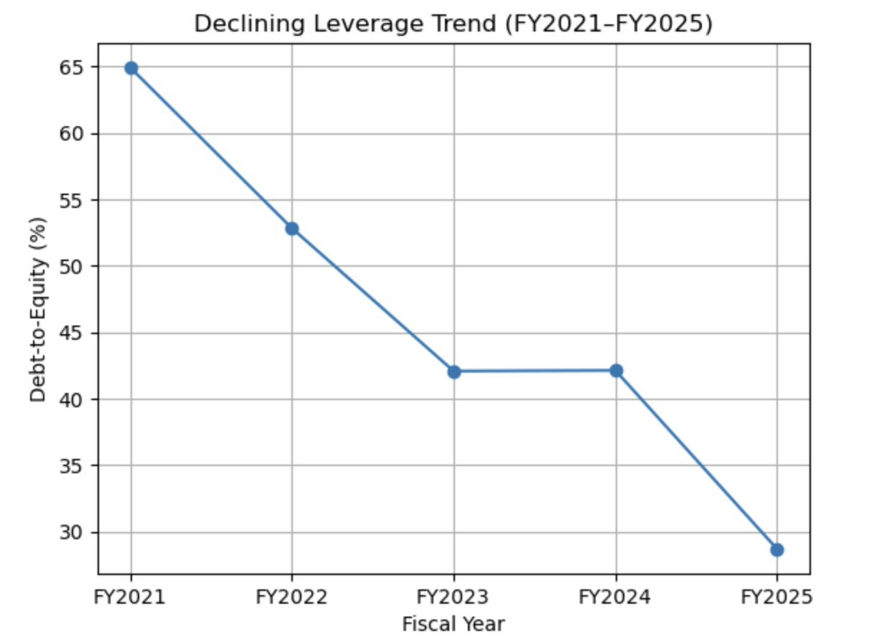

Figure 8 illustrates a clear downward trend in Costco’s debt-to-equity ratio, highlighting deliberate deleveraging over the five-year period. This reduction in leverage enhances financial flexibility and lowers financial risk, positioning the company to fund growth opportunities without reliance on external borrowing.

## 10.2 Debt-to-Assets Ratio

The debt-to-assets ratio measures leverage relative to total assets.

**Table 22: Debt-to-Assets Analysis**

|  |  |  |  |  |  |
| --- | --- | --- | --- | --- | --- |
| **Fiscal Year** | **2021** | **2022** | **2023** | **2024** | **2025** |
| Total Debt ($M) | 11,407 | 10,906 | 10,536 | 9,949 | 8,358 |
| Total Assets ($M) | 59,268 | 64,166 | 68,988 | 69,831 | 77,099 |
| **Debt/Assets** | **19.25%** | **17.00%** | **15.27%** | **14.25%** | **10.84%** |

Table 22: Debt as percentage of assets

The debt-to-assets ratio declined from 19.25% to 10.84%, indicating debt represents only 10.84% of total assets an exceptionally conservative capital structure.

## 

## 10.3 Equity Ratio

The equity ratio measures the proportion of assets financed by shareholders' equity.

**Table 23: Equity Ratio Analysis**

|  |  |  |  |  |  |
| --- | --- | --- | --- | --- | --- |
| **Fiscal Year** | **2021** | **2022** | **2023** | **2024** | **2025** |
| Stockholders' Equity ($M) | 17,561 | 20,642 | 25,045 | 23,622 | 29,164 |
| Total Assets ($M) | 59,268 | 64,166 | 68,988 | 69,831 | 77,099 |
| **Equity Ratio** | **29.63%** | **32.17%** | **36.31%** | **33.83%** | **37.82%** |

Table 23: Equity financing proportion

The equity ratio improved from 29.63% to 37.82%, indicating that nearly 38% of assets are financed by shareholders' equity a strong and improving capital base.

## 10.4 Interest Coverage Ratio

Interest coverage measure’s ability to service debt. Interest Coverage = Operating Income ÷ Interest Expense.

**Table 24: Interest Coverage Analysis**

|  |  |  |  |  |  |
| --- | --- | --- | --- | --- | --- |
| **Fiscal Year** | **2021** | **2022** | **2023** | **2024** | **2025** |
| Operating Income ($M) | 6,708 | 7,793 | 8,112 | 9,285 | 10,383 |
| Interest Expense ($M) | 171 | 158 | 160 | 169 | 154 |
| **Interest Coverage** | **39.2x** | **49.3x** | **50.7x** | **54.9x** | **67.4x** |

Table 24: Debt service coverage

Interest coverage of 67.4x in fiscal 2025 indicates operating income covers interest expense 67 times over exceptional debt service capacity. This ratio demonstrates:

* Minimal financial risk from debt obligations
* Substantial capacity to take on additional debt if needed
* No meaningful constraint on operational or strategic flexibility

## 10.5 Net Debt Position

Net debt (total debt - cash and investments) provides a more refined view of financial position.

**Table 25: Net Debt Analysis**

|  |  |  |  |  |  |
| --- | --- | --- | --- | --- | --- |
| **Metric ($M)** | **FY2021** | **FY2022** | **FY2023** | **FY2024** | **FY2025** |
| Total Debt | 11,407 | 10,906 | 10,536 | 9,949 | 8,358 |
| Cash & Investments | 12,175 | 11,049 | 15,234 | 11,144 | 15,175 |
| **Net Debt** | **-768** | **-143** | **-4,698** | **-1,195** | **-6,817** |

Table 25: Net debt/(cash) position

Costco maintains a net cash position (negative net debt) in all periods, with fiscal 2025 showing net cash of $6.8 billion. This demonstrates:

* Financial strength and flexibility
* No dependency on debt financing
* Ability to fund operations, growth, and shareholder returns from internal cash generation
* Strategic optionality for acquisitions or major investments

## 10.6 Capital Structure Summary

Costco's capital structure demonstrates exceptional financial strength:

1. Debt-to-equity of 28.66% represents very conservative leverage
2. Interest coverage of 67.4x indicates minimal financial risk
3. Net cash position of $6.8 billion provides substantial financial cushion
4. Equity ratio of 37.82% demonstrates strong capital base
5. Declining debt levels reflect deleveraging strategy
6. Financial flexibility to pursue growth opportunities or weather economic downturns

This conservative capital structure is appropriate for Costco's business model and provides strategic flexibility while maintaining investment-grade credit ratings.

# 11. Cash flow analysis

## 11.1 Operating Cash Flow

Operating cash flow measures cash generated from core business operations.

**Table 26: Operating Cash Flow Analysis**

|  |  |  |  |  |  |
| --- | --- | --- | --- | --- | --- |
| **Metric ($M)** | **FY2021** | **FY2022** | **FY2023** | **FY2024** | **FY2025** |
| Net Income | 5,007 | 5,844 | 6,292 | 7,367 | 8,099 |
| Operating Cash Flow | 8,958 | 7,392 | 11,068 | 11,339 | 13,335 |
| OCF/Net Income | 1.79x | 1.26x | 1.76x | 1.54x | 1.65x |

Table 26: Operating cash flow generation

Operating cash flow of $13.3 billion in fiscal 2025 represents:

* 48.5% growth versus fiscal 2021 ($9.0 billion)
* 1.65x net income conversion, indicating high-quality earnings
* 17.6% increase versus fiscal 2024

The strong and growing operating cash flow reflects:

* Strong profitability growth
* Working capital efficiency (negative cash conversion cycle)
* High cash conversion from net income

## 11.2 Capital Expenditures and Free Cash Flow

Free cash flow (operating cash flow - capital expenditures) measures cash available for shareholder distributions and debt reduction after funding growth investments.

**Table 27: Free Cash Flow Analysis**

|  |  |  |  |  |  |
| --- | --- | --- | --- | --- | --- |
| **Metric ($M)** | **FY2021** | **FY2022** | **FY2023** | **FY2024** | **FY2025** |
| Operating Cash Flow | 8,958 | 7,392 | 11,068 | 11,339 | 13,335 |
| Capital Expenditures | 3,588 | 3,891 | 4,319 | 4,710 | 5,498 |
| **Free Cash Flow** | **5,370** | **3,501** | **6,749** | **6,629** | **7,837** |
| FCF/Net Income | 1.07x | 0.60x | 1.07x | 0.90x | 0.97x |
| Capex/Sales | 1.9% | 1.7% | 1.8% | 1.9% | 2.0% |

Table 27: Free cash flow and capital intensity

Free cash flow of $7.8 billion in fiscal 2025 funded:

* Dividends: $2.2 billion
* Share repurchases: $903 million
* Debt reduction: $103 million
* With substantial cash remaining for balance sheet strengthening

Capital expenditures of $5.5 billion (2.0% of sales) funded:

* 24 net new warehouse openings
* Remodels and upgrades to existing warehouses
* Technology and infrastructure investments
* Distribution and logistics capabilities

The relatively modest capital intensity (capex as % of sales) demonstrates the efficiency of Costco's warehouse model.

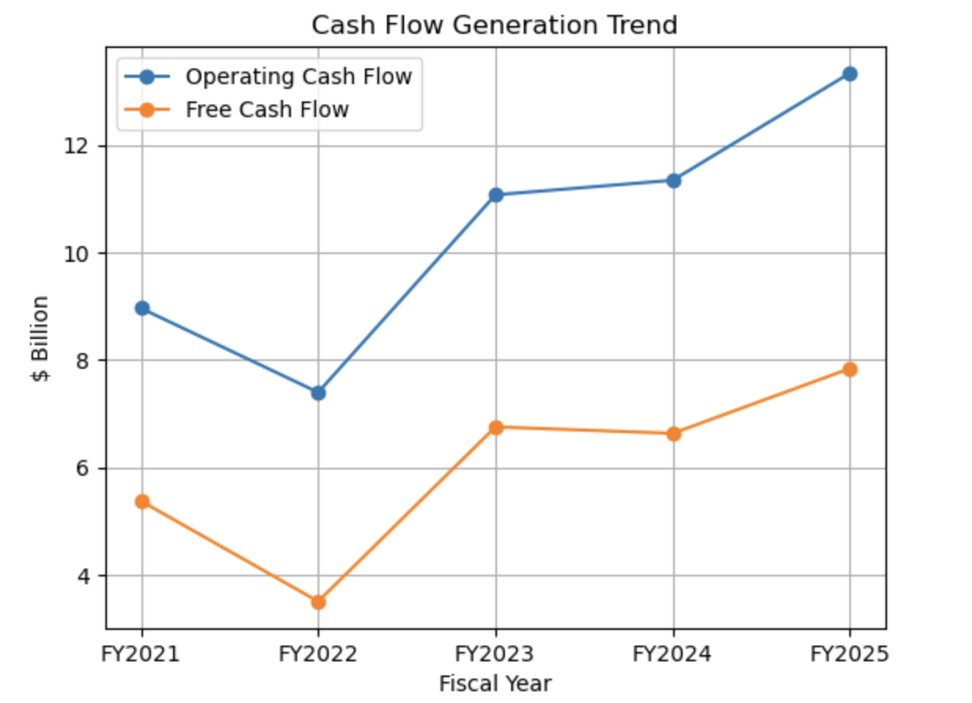Chart 9: Operating Cash Flow vs Free Cash Flow

Figure 9 demonstrates strong and improving operating and free cash flow generation. The widening gap between operating cash flow and capital expenditure indicates Costco’s ability to internally fund expansion while continuing shareholder distributions. This confirms the high quality and sustainability of earnings.

## 11.3 Cash Flow Allocation

Costco's capital allocation priorities in fiscal 2025:

1. **Growth Investment:** $5.5 billion in capital expenditures for new warehouses and infrastructure
2. **Shareholder Distributions:** $3.1 billion total ($2.2B dividends + $0.9B buybacks)
3. **Debt Management:** $103 million in long-term debt reduction
4. **Balance Sheet Strengthening:** Remaining cash to strengthen financial position

## 11.4 Cash Flow Quality

Several metrics indicate high-quality cash flows:

* **OCF/Net Income ratio of 1.65x:** Cash earnings exceed accounting earnings
* **Consistent generation:** Positive operating cash flow in all periods
* **Growth trajectory:** Operating cash flow growing faster than net income
* **Free cash flow positive:** Strong cash generation after growth investments

## 11.5 Cash Flow Analysis Summary

Costco's cash flow profile demonstrates:

1. Robust and growing operating cash flow ($13.3 billion in fiscal 2025)
2. Strong free cash flow generation ($7.8 billion)
3. Efficient capital deployment (2.0% capex intensity)
4. Balanced allocation between growth and shareholder returns
5. High cash conversion from net income
6. Financial flexibility from strong cash generation

The strong cash generation supports Costco's growth strategy while enabling substantial shareholder returns and financial strength.

# 12. Sustainable growth analysis

## 12.1 Sustainable Growth Rate

The sustainable growth rate (SGR) estimates the maximum growth rate achievable using internally generated funds without increasing financial leverage.

**Sustainable Growth Rate = ROE × (1 - Dividend Payout Ratio)**

For Fiscal 2025:

* ROE = 27.75%
* Total Dividends = $2,183 million
* Net Income = $8,099 million
* Dividend Payout Ratio = $2,183M / $8,099M = 26.95%
* Retention Ratio = 1 - 0.2695 = 73.05%

**SGR = 27.75% × 73.05% = 20.27%**

This indicates Costco can sustainably grow at approximately 20% annually using retained earnings without increasing leverage or requiring external financing.

## 

## 12.2 Actual Growth vs. Sustainable Growth

**Table 28: Actual Growth Performance**

|  |  |  |  |  |
| --- | --- | --- | --- | --- |
| **Metric** | **FY2022** | **FY2023** | **FY2024** | **FY2025** |
| Revenue Growth | 15.8% | 6.8% | 5.0% | 8.1% |
| Asset Growth | 8.3% | 7.5% | 1.2% | 10.4% |
| Equity Growth | 17.5% | 21.3% | -5.7% | 23.5% |
| Sustainable Growth | ~20% | ~18% | ~23% | ~20% |

Table 28: Actual versus sustainable growth rates

Observations:

1. **Growth Below SGR:** In most years, actual revenue and asset growth have been below sustainable growth rate, indicating Costco is not financially constrained
2. **Financial Flexibility:** The gap between sustainable and actual growth provides flexibility for special dividends, share repurchases, or accelerated expansion
3. **Conservative Leverage:** Costco could grow faster by utilizing more leverage, but chooses conservative capital structure

## 12.3 Capital Allocation Framework

Costco's capital allocation priorities:

1. **Growth Investment:** New warehouse openings (20-30 annually), infrastructure, technology
2. **Operational Excellence:** Remodels, upgrades, efficiency improvements
3. **Regular Dividends:** Consistent quarterly dividends (currently $1.16/share quarterly)
4. **Opportunistic Buybacks:** Share repurchases when valuations are attractive
5. **Special Dividends:** Periodic special dividends (historically every 2-3 years)
6. **Balance Sheet Strength:** Maintain conservative leverage and strong liquidity

## 12.4 Growth Capacity Assessment

Costco possesses substantial capacity for continued growth:

**Financial Capacity:**

* Strong free cash flow ($7.8 billion annually)
* Minimal debt levels (28.7% debt-to-equity)
* Large, untapped debt capacity
* Sustainable growth rate of 20% exceeds actual growth needs

**Operational Capacity:**

* Proven warehouse expansion model
* Strong unit economics (high returns on new warehouses)
* Scalable business model
* Growing e-commerce capabilities

**Market Opportunity:**

* International expansion (China, emerging markets)
* Further U.S. penetration (underserved markets)
* E-commerce growth (15.6% growth in fiscal 2025)
* Category expansion and services

## 12.5 Long-Term Growth Outlook

Based on sustainable growth analysis, Costco can support:

* **Near-term (3-5 years):** 6-8% annual revenue growth through combination of comparable sales growth (3-5%), new warehouse openings (2-3%), and e-commerce expansion
* **Medium-term (5-10 years):** Continued steady growth as international markets mature and e-commerce scales
* **Long-term:** Growth potential supported by strong unit economics, expansion opportunities, and financial flexibility

## 12.6 Sustainable Growth Summary

Costco's sustainable growth analysis reveals:

1. Sustainable growth rate of ~20% provides ample capacity for actual growth needs
2. Financial position enables balanced approach to growth and shareholder returns
3. Conservative leverage provides safety margin and strategic flexibility
4. Strong free cash flow supports growth without external financing needs
5. Substantial market opportunity supports long-term growth trajectory

# 13. Strategic developments in fiscal 2025

## 

## 13.1 Membership Fee Increase

In September 2024, Costco implemented its first membership fee increase since June 2017 a strategic milestone with significant financial impact.

**Fee Changes:**

* Gold Star membership: $60 → $65 (+8.3%)
* Business membership: $60 → $65 (+8.3%)
* Executive membership: $120 → $130 (+8.3%)
* Executive reward cap: $1,000 → $1,250

**Financial Impact:**

* Membership fees increased 10.3% to $5.3 billion in fiscal 2025
* Fee increase contributed approximately 50% of membership fee growth
* Remaining 50% from membership base growth and Executive upgrades
* Minimal impact on renewal rates (remained >90% globally)

**Strategic Rationale:**

The timing and magnitude of the increase demonstrated pricing power while maintaining member value proposition. The 7-year gap between increases (versus typical 5.5-year cadence) showed restraint and member sensitivity.

## 13.2 Warehouse Expansion

Fiscal 2025 saw accelerated warehouse expansion with 24 net new locations:

**Global Expansion:**

* Total warehouses: 914 (versus 861 at end of fiscal 2024)
* U.S. openings: Continued penetration in existing and new markets
* International growth: Expansion in China, Japan, Korea, and other markets
* Format innovation: Testing smaller urban formats in select markets

**Expansion Economics:**

* Average warehouse investment: $15-20 million
* Payback period: 5-7 years typical
* Mature warehouse sales: $150-250 million annually
* Strong returns on invested capital

## 13.3 E-Commerce Growth

E-commerce continued strong growth trajectory:

**Fiscal 2025 Performance:**

* E-commerce sales growth: 15.6% (16.1% excluding gas/FX)
* Significantly outpaced in-warehouse growth
* Improved profitability from e-commerce operations
* Investments in logistics and fulfillment capabilities

**Strategic Initiatives:**

* Same-day delivery expansion (partnership networks)
* Buy-online-pickup-in-warehouse (BOPUS) growth
* Digital marketing and personalization
* Mobile app enhancements
* Costco Next (expanded online marketplace)

## 13.4 Operational Excellence Initiatives

Fiscal 2025 saw continued focus on operational improvements:

**Fresh Foods Excellence:**

* Margin improvement in fresh foods (19 basis point contribution to overall gross margin)
* Enhanced quality and assortment
* Improved shrink management
* Supply chain optimization

**Technology Investments:**

* Warehouse management systems upgrades
* Member experience enhancements
* Data analytics and personalization
* Self-checkout expansion

**Sustainability Initiatives:**

* Renewable energy installations
* Waste reduction programs
* Sustainable sourcing commitments
* Carbon footprint reduction targets

## 13.5 International Market Development

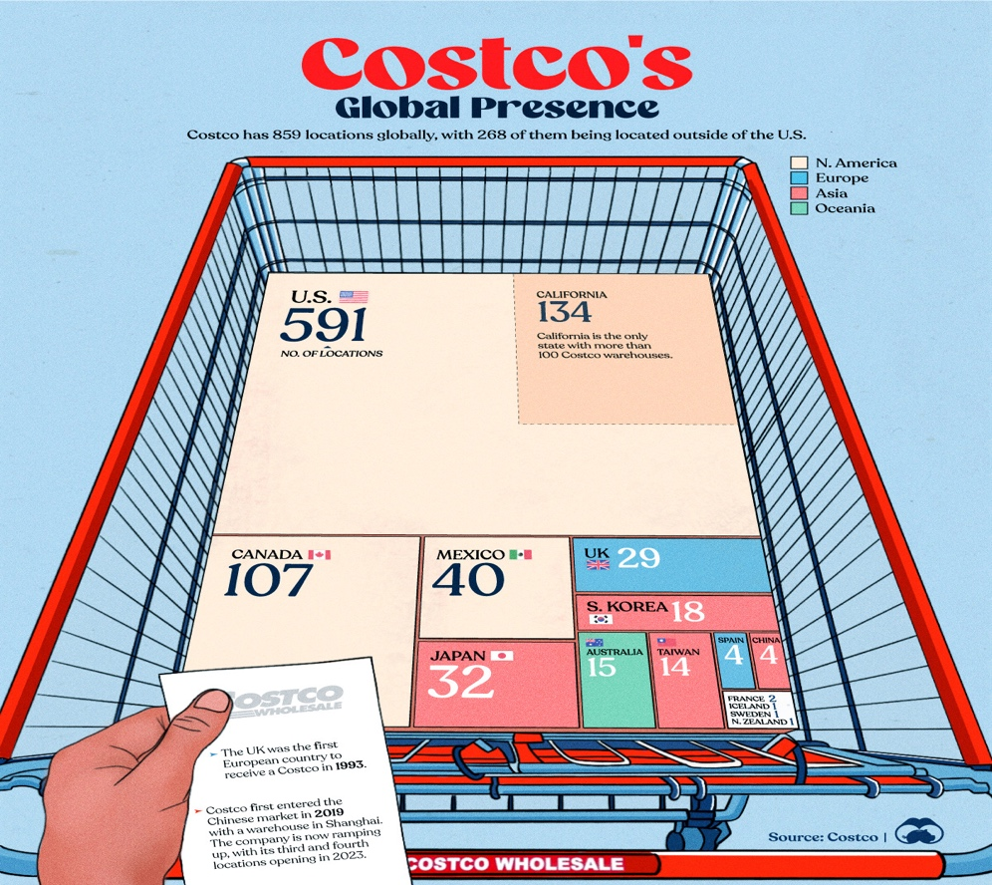

International markets continued to drive growth:

**Performance Highlights:**

* Canada: Strong comparable sales (8.3% adjusted for FX)
* Other International: 8.2% adjusted comparable sales growth
* China expansion: New warehouse openings in key cities
* Market adaptation: Localized product offerings

**Growth Opportunity:**

* International represents ~30% of warehouses but substantial growth runway
* Emerging middle class in Asia
* Warehouse club format gaining acceptance globally
* Leveraging proven model with local adaptation

## 13.6 Financial Services and Ancillaries

Ancillary businesses contributed to overall performance:

**Co-branded Credit Card:**

* Significant contributor to gross margin improvement
* Enhanced rewards program driving engagement
* Increased penetration of Executive members

**Services Growth:**

* Gasoline: Maintained price advantage driving traffic
* Pharmacy: Strong growth in prescriptions and services
* Optical and hearing aids: Market share gains
* Travel services: Recovery post-pandemic

# 14. Risk factors and considerations

## 14.1 Macroeconomic Risks

**Economic Downturn:** Recession or prolonged economic weakness could reduce consumer spending, particularly on discretionary items. However, Costco's value proposition typically strengthens during economic stress as consumers seek savings.

**Inflation/Deflation:** High inflation can pressure margins if Costco cannot pass costs through while maintaining value perception. Deflation can reduce sales growth. Fiscal 2025 showed effective inflation management.

**Interest Rates:** While Costco has minimal debt, rising rates affect consumer purchasing power and borrowing costs for growth investments. Current low debt levels mitigate this risk.

## 14.2 Competitive Risks

**E-Commerce Competition:** Amazon and other e-commerce platforms pose ongoing competitive threat, particularly in non-perishable categories. Costco's omnichannel approach and membership model provide differentiation.

**Warehouse Club Competition:** Sam's Club and BJ's compete directly. Costco has maintained competitive advantages through execution excellence, but intensified competition could pressure margins or market share.

**Traditional Retail Evolution:** Walmart, Target, and regional grocers continue investing in value propositions and digital capabilities. Costco must maintain differentiation through unique member experience.

**Discount Grocers:** Aldi, Lidl, and other hard discount formats provide alternative value propositions that could attract price-sensitive consumers.

## 14.3 Operational Risks

**Supply Chain Disruptions:** Global supply chain volatility (demonstrated during pandemic) can impact product availability and costs. Costco's supplier relationships and inventory management help mitigate but cannot eliminate this risk.

**Labor Costs and Availability:** Costco's above-market compensation strategy, while creating competitive advantages, makes the company more sensitive to wage inflation. Tight labor markets could pressure margins.

**Real Estate Constraints:** Finding suitable warehouse sites in desirable locations becomes increasingly challenging. Development costs and timing can impact expansion plans.

**Technology Systems:** Increasing reliance on technology for operations, e-commerce, and member experience creates cybersecurity and operational risks. Significant technology failures could disrupt operations.

## 

## 14.4 Regulatory and Legal Risks

**Labor Regulations:** Changes in minimum wage laws, benefits requirements, or unionization could increase labor costs, though Costco's current practices exceed most regulatory requirements.

**Data Privacy and Security:** Handling member data creates regulatory compliance obligations (GDPR, CCPA) and cybersecurity risks. Breaches could harm reputation and create financial liability.

**Product Liability:** As a retailer, Costco faces product liability risks, particularly for food products and private-label Kirkland items. Quality control and insurance programs help manage these risks.

**International Regulations:** Operating globally exposes Costco to diverse regulatory environments including trade policies, tariffs, and local business regulations.

## 14.5 Strategic Risks

**Membership Model Vulnerability:** If competitors successfully replicate the warehouse club model or consumers shift preference away from membership-based shopping, Costco's fundamental business model could be challenged.

**E-Commerce Transition:** Failure to successfully scale e-commerce while maintaining warehouse productivity could allow competitors to gain advantage. Balancing online and offline strategies is critical.

**International Expansion Execution:** Expanding into new international markets carries execution risks including cultural adaptation, regulatory navigation, and competitive dynamics.

**Brand and Reputation:** Costco's brand value and member loyalty are core assets. Negative events (food safety, labor issues, data breaches) could damage reputation and member trust.

## 14.6 Financial Risks

**Currency Fluctuations:** International operations create foreign exchange exposure. In fiscal 2025, FX impacts reduced net sales by 78 basis points, demonstrating ongoing currency risk.

**Pension and Benefits Obligations:** Employee benefit commitments create long-term obligations. While well-funded currently, market or demographic changes could increase costs.

**Capital Allocation:** Balancing growth investment, shareholder returns, and financial flexibility requires disciplined capital allocation. Missteps could destroy shareholder value.

## 14.7 Risk Mitigation Factors

Costco possesses several risk mitigation factors:

1. Strong balance sheet ($15.2 billion cash, minimal debt) provides financial cushion
2. Diversified revenue streams (merchandise categories, geographies, ancillary services)
3. Proven business model with 40+ year track record
4. Industry-leading member loyalty and retention (>90% renewal rates)
5. Operational excellence and efficiency advantages
6. Conservative management and disciplined decision-making
7. Strong corporate culture and employee relations

# 15. Conclusions and investment implications

## 15.1 Financial Performance Summary

The comprehensive financial analysis of Costco Wholesale Corporation for fiscal years 2021-2025 reveals exceptional and improving performance across all key dimensions:

**Revenue Growth:** Total revenue grew 40.5% from $195.9 billion to $275.2 billion, demonstrating sustained top-line momentum despite challenging macroeconomic conditions.

**Profitability Expansion:** Net income increased 61.8% from $5.0 billion to $8.1 billion, significantly outpacing revenue growth and demonstrating powerful operating leverage. Net margin improved from 2.61% to 3.00%.

**Return Metrics:** Return on equity remained strong at 27.75%, while return on assets improved to 10.51% both significantly above retail industry averages.

**Financial Strength:** The balance sheet strengthened substantially with stockholders' equity growing 65.9% to $29.2 billion, debt-to-equity declining to 28.66%, and net cash position reaching $6.8 billion.

**Cash Generation:** Operating cash flow grew to $13.3 billion with free cash flow of $7.8 billion, funding growth investments and substantial shareholder returns.

**Operational Excellence:** Inventory turnover of 13.24x, asset turnover of 3.50x, and negative cash conversion cycle demonstrate world-class operational efficiency.

## 15.2 Competitive Position Assessment

Costco's competitive position has strengthened over the analysis period:

**Membership Economics:** The successful September 2024 fee increase demonstrated pricing power while maintaining industry-leading renewal rates above 90%. Membership fees grew 36.9% to $5.3 billion.

**Scale Advantages:** As one of the world's largest retailers with $270 billion in sales, Costco commands exceptional purchasing leverage that translates into member value.

**Brand Strength:** Kirkland Signature has become one of retail's most valuable private labels, generating over $60 billion in sales and reinforcing member loyalty.

**Operational Efficiency:** Costco's limited SKU strategy, warehouse productivity, and rapid inventory turnover create durable cost advantages.

**Member Loyalty:** Renewal rates exceeding 90% globally (92%+ in U.S./Canada) demonstrate strong member satisfaction and create predictable, recurring revenue.

**Financial Flexibility:** Minimal debt, strong cash generation, and fortress balance sheet provide strategic optionality unavailable to more leveraged competitors.

## 15.3 Business Model Durability

The analysis confirms the durability and sustainability of Costco's business model:

1. **Membership Flywheel:** The self-reinforcing cycle of low prices → high retention → purchasing power → low prices continue to build momentum
2. **Balanced Economics:** The combination of high-margin membership fees and thin-margin merchandise sales creates a sustainable profit structure
3. **Value Proposition:** Consistent delivery of genuine value to members supports long-term loyalty even as competitive dynamics evolve
4. **Scalability:** The warehouse club model scales effectively across geographies and market conditions
5. **Adaptability:** Successful e-commerce integration and format innovation demonstrate ability to evolve while maintaining core principles

## 15.4 Growth Trajectory

Costco possesses substantial capacity for continued growth:

**Near-Term Growth Drivers:**

* Warehouse expansion (20-30 net new annually)
* E-commerce scaling (15.6% growth in fiscal 2025)
* International market development (especially China and emerging markets)
* Membership base expansion (Executive member penetration)
* Comparable sales growth (mid-single digits sustainable)

**Financial Capacity:**

* Sustainable growth rate of ~20% exceeds actual growth requirements
* Strong free cash flow ($7.8 billion) funds expansion without external financing
* Minimal leverage provides debt capacity if needed
* Proven unit economics on new warehouse investments

**Market Opportunity:**

* International represents ~30% of warehouses with significant runway
* E-commerce penetration still early stage versus potential
* U.S. market underpenetrated in certain geographies
* Category and service expansion opportunities

## 15.5 Investment Considerations

**Strengths:**

* Exceptional and improving financial performance
* Durable competitive advantages and widening moat
* Industry-leading operational efficiency
* Strong balance sheet and cash generation
* Sustainable business model with long track record
* Disciplined management and capital allocation
* Significant growth runway domestically and internationally

**Considerations:**

* Valuation multiples typically at premium to retail sector (reflects quality)
* Low absolute profit margins create limited room for operational missteps
* Mature U.S. market requires international expansion for sustained high growth
* Competitive threats from e-commerce and evolving retail landscape
* Execution risk on international expansion and e-commerce integration

## 15.6 Final Assessment

Costco Wholesale Corporation demonstrates characteristics of an exceptional retail business:

**Quality of Business (Excellent):**

* Durable competitive advantages
* High returns on capital (ROE 27.75%, ROA 10.51%)
* Strong cash generation and financial flexibility
* Proven and sustainable business model
* Industry-leading operational metrics

**Financial Strength (Excellent):**

* Fortress balance sheet with net cash position
* Conservative leverage (28.7% debt-to-equity)
* Strong and growing cash flows
* Investment-grade credit quality
* No financial constraints on growth or shareholder returns

**Growth Prospects (Strong):**

* Multiple growth drivers (warehouses, e-commerce, international)
* Substantial market opportunity
* Financial capacity to fund growth
* Proven ability to execute expansion
* Sustainable growth rate exceeds current growth

**Management Quality (Excellent):**

* Long-term orientation and strategic consistency
* Disciplined capital allocation
* Member-centric culture
* Conservative financial management
* Track record of value creation

**Risk Profile (Moderate):**

* Macroeconomic sensitivity mitigated by value proposition
* Competitive threats offset by strong competitive position
* Operational excellence reduces execution risk
* Financial strength provides resilience
* Overall risk profile appropriate for business quality

## 15.7 Investment Recommendation Framework

Based on the comprehensive financial analysis, Costco Wholesale Corporation represents a high-quality retail business with:

* **Strong historical performance** (61.8% net income growth over 5 years)
* **Excellent financial strength** (net cash position, minimal leverage)
* **Durable competitive advantages** (scale, brand, loyalty, efficiency)
* **Attractive growth prospects** (international, e-commerce, new warehouses)
* **Superior management** (disciplined, member-focused, long-term oriented)

The combination of quality, growth, and financial strength positions Costco as a compelling long-term investment opportunity, though investors should consider valuation in context of these characteristics.

For investors seeking:

* **Quality:** Costco ranks among the highest quality retail businesses globally
* **Growth:** Multiple growth drivers support sustained revenue and earnings expansion
* **Financial Stability:** Fortress balance sheet and strong cash flows provide security
* **Long-Term Compounding:** Business model supports sustained value creation over time

The financial analysis confirms that Costco's business model, competitive position, financial strength, and growth prospects justify consideration as a core long-term holding in a diversified investment portfolio.

# References

Costco Wholesale Corporation. (2025). Form 10-K Annual Report for Fiscal Year Ended August 31, 2025. U.S. Securities and Exchange Commission.

Costco Wholesale Corporation. (2025, September 25). Costco Wholesale Corporation Reports Fourth Quarter and Fiscal Year 2025 Operating Results [Press release]. <https://investor.costco.com/news>

Costco Wholesale Corporation. (2025, November 24). Costco Membership Fees Surge in 2025: What Investors Should Track Next. *Yahoo Finance*. <https://finance.yahoo.com/news/costco-membership-fees-surge-2025>

Costco Wholesale Corporation. (2024). Form 10-K Annual Report for Fiscal Year Ended September 1, 2024. U.S. Securities and Exchange Commission.

Stock Analysis. (2025, August 21). Costco (COST) Balance Sheet. <https://stockanalysis.com/stocks/cost/financials/balance-sheet/>

MarketScreener. (2025, October 8). Costco Wholesale Corporation: Annual Report for Fiscal Year Ending 08/31/2025 (Form 10-K). <https://www.marketscreener.com/news/costco-wholesale-annual-report>

Moomoo AI. (2025, October 8). Costco | 10-K: FY2025 Annual Report. <https://www.moomoo.com/news/notice/305640659>

TipRanks. (2025, August 8). Costco (COST) Financial Statements, Cash Flow and Balance Sheet. <https://www.tipranks.com/stocks/cost/financials>

SEC EDGAR. (2025, September 24). Costco Wholesale Corp Form 10-K. <https://www.sec.gov/Archives/edgar/data/909832/000090983225000093/>

Stock Analysis on Net. (2025, October 7). Costco Wholesale Corp. (NASDAQ:COST) Balance Sheet: Assets. <https://www.stock-analysis-on.net/NASDAQ/Company/Costco-Wholesale-Corp/>

Bloomberg. (2025, September 25). Costco's Earnings Beat Estimates on Steady Consumer Demand. <https://www.bloomberg.com/news/articles/2025-09-25/>

CNBC. (2025, December 11). Costco tops Wall Street's sales and revenue expectations. <https://www.cnbc.com/2025/12/11/costco-cost-earnings-q1-2026.html>